LUXURY STAY

(Hotel Management)

Developer Guide


GROUP MEMBERS

Student 1571110 | Naveera Hanif
Student 1571109 | Mahnoor
Student 1501307 | Sunaina Shahid
Student 1547290 | Syeda Shama Iqbal


CURRICULUM: ACCP PRIME 2.0
SEMESTER: ADSE
FACULTY: Sir Muhammad Noman Siddiqui

CERTIFICATE OF RECOGNITION

This certificate is awarded to the developers of LuxuryStay for their outstanding contribution to the world of Fintech and Digital Innovation.

The recognition of LuxuryStay refers to an award for its achievements in providing real-time exchange rates, seamless currency conversion, and an exceptional user experience. This includes factors such as ensuring data accuracy, promoting financial transparency, and providing accessible tools for global users.
A recognition of this kind serves as a testament to the hard work and dedication of the LuxuryStay development team and management, and helps to establish LuxuryStay as a leader in the digital currency solutions industry.


15-Oct-2026
PRESENTED ON:

FACULTY:
SIR NOMAN SIDDIQUI

We would like to express our sincere gratitude to everyone who has contributed to the successful completion of this project.

Our heartfelt thanks goes to Sir Noman for providing invaluable guidance and support throughout the whole process.
We are deeply grateful to our group members for their hard work, dedication, and collaboration. Their efforts have been instrumental in bringing LuxuryStay to fruition.
We would also like to thank our families for their love and support, which has allowed us to stay focused and motivated.
Finally, we extend our thanks to all those who have provided us with the resources and opportunities necessary to complete this project.
This project would not have been possible without the help and support of all of you. THANK YOU.

PROBLEM STATEMENT:
LuxuryStay is a high-end hotel chain known for its exceptional service and luxurious accommodations. Currently, hotel management operations face difficulties in streamlining room reservations, real-time status updates, and centralized guest management across multiple hotel locations through a single, reliable platform.
To solve this, LuxuryStay aims to implement a modern, responsive, and scalable digital web application. The platform centralizes all room inventory management, real-time availability tracking, guest services, dynamic billing, and automated system notifications to elevate operational efficiency and guest experience.


SITE MAP:

HOME (Landing Page)

----------------+--------------+--------------------------------- ---+--------------------------+------
| | | |
[ ROOMS & SUITES ] [ ABOUT US ] [ SERVICES & AMENITIES ] [ CONTACT US ]
|
[ Room Details & Availability ]
|
[ Book Now / Reservation Form ]
|
[ Payment & Confirmation ]

[ USER DASHBOARD ]

+----------------------+-----------------------------+---------------------------------+
| | | |
[ MY RESERVATIONS ] [ PROFILE ] [ GUEST REQUESTS ] [ NOTIFICATIONS ]
- Past Bookings - Edit Profile - Room Service - Booking Alerts
- Active Stays - Account Settings - Maintenance Request - Status Updates
- Cancel Booking - Logout - Feedback & Ratings

[ ADMIN / STAFF DASHBOARD ]

+------------------------------------+---------------------------------+--------------------------------+
| | | |
[ ROOM MANAGEMENT ] [ RESERVATION CONTROL ] [ HOUSEKEEPING ] [ ANALYTICS & REPORTS ]
- Inventory Setup - View All Bookings - Cleaning Tasks - Occupancy Rates
- Pricing & Rates - Check-In / Check-Out - Status Updates - Revenue Trends
- Status Tracking - Assign Rooms - Maintenance Logs - Guest Insights
|
[ STAFF PROFILES ]
- Manager, Receptionist, Housekeeping Roles

CHECKLIST OF VALIDATION:

Option | Validation
Do all navigation icons lead to the appropriate screens? | YES
Does the room search & booking system show accurate pricing and availability? | YES
Are all real-time analytics graphs (occupancy/revenue) clearly visible on the dashboard? | YES
Is the web application opening properly across all tested web browsers (Chrome, Firefox, Edge)? | YES
Are notification badges updating in real-time for new bookings and alerts? | YES
Is the user interface responsive on different screen sizes? | YES
Is the application taking too long to load data? | NO
Is the data being stored correctly in the MongoDB database? | YES
Is the logout functionality working as expected? | YES

SIGN UP / LOGIN FORM:

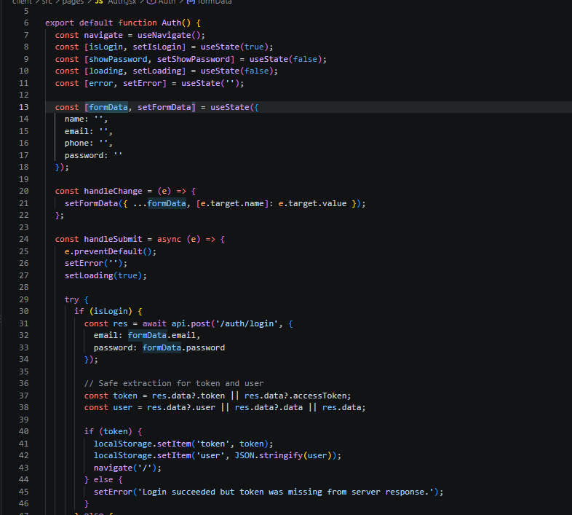

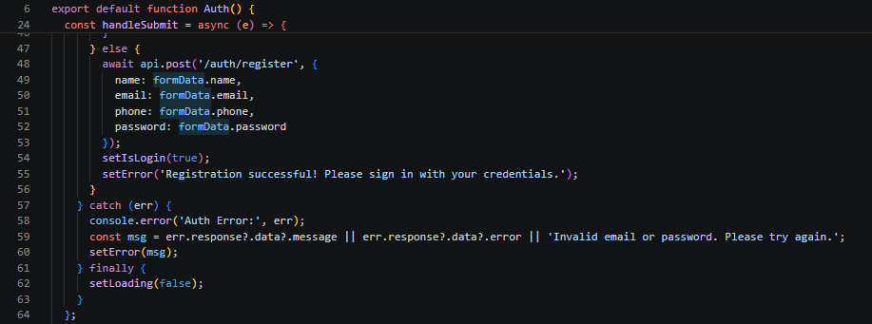
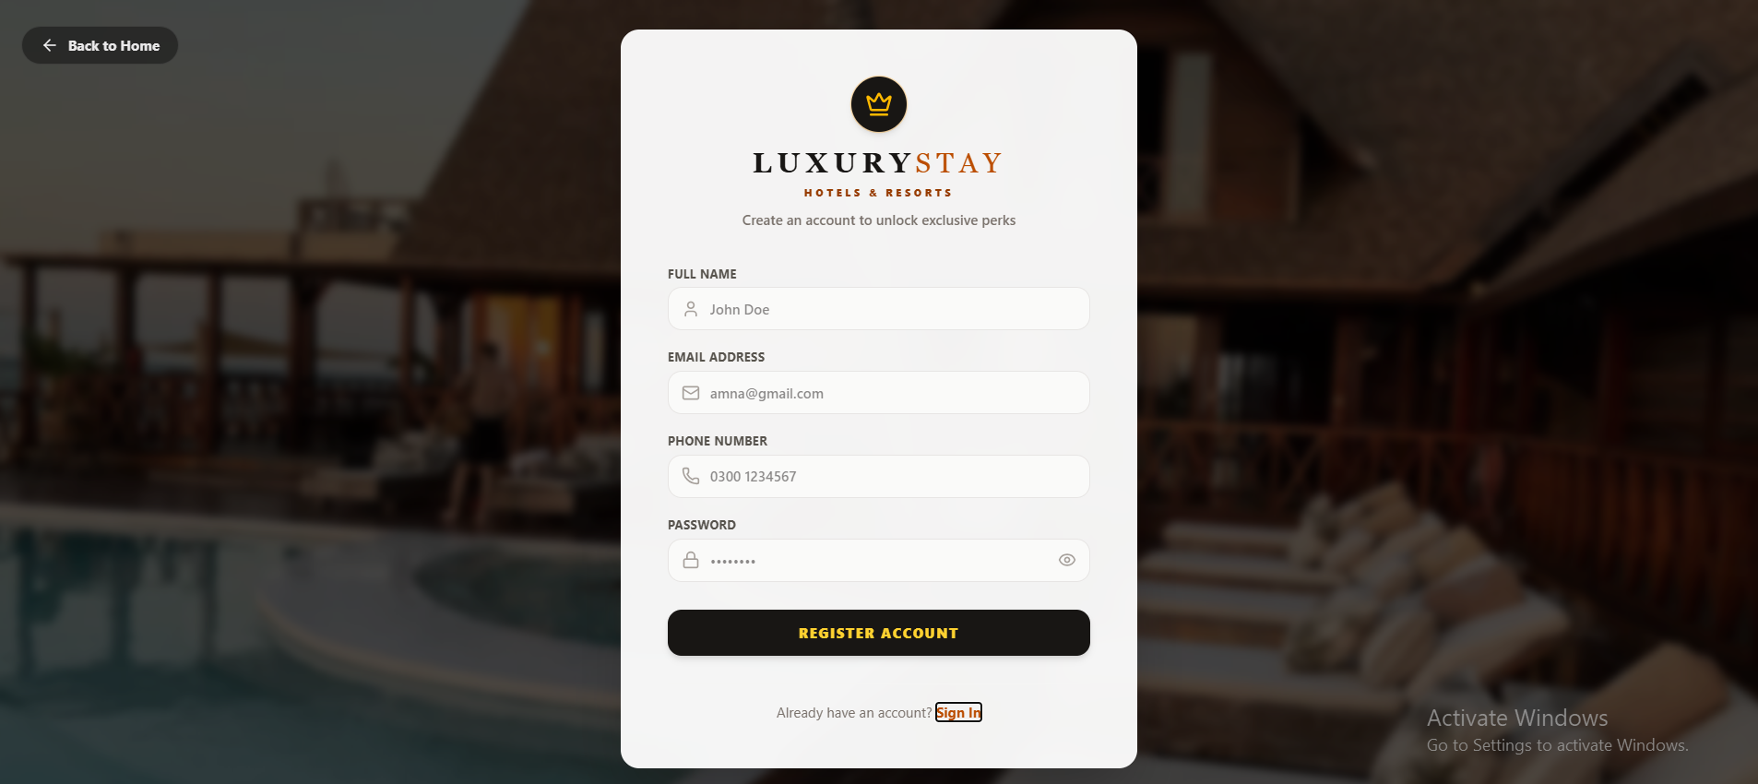

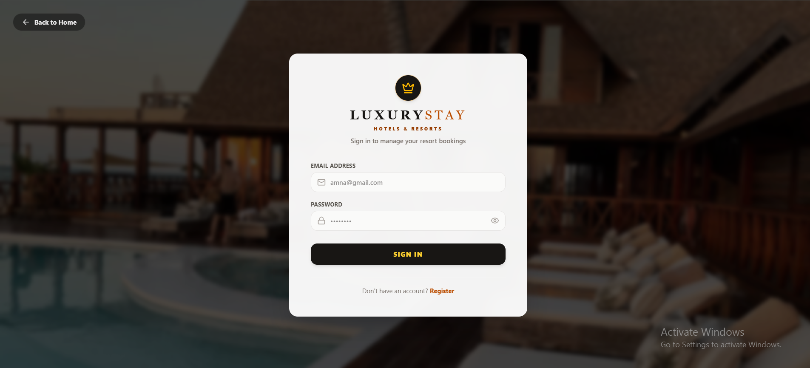

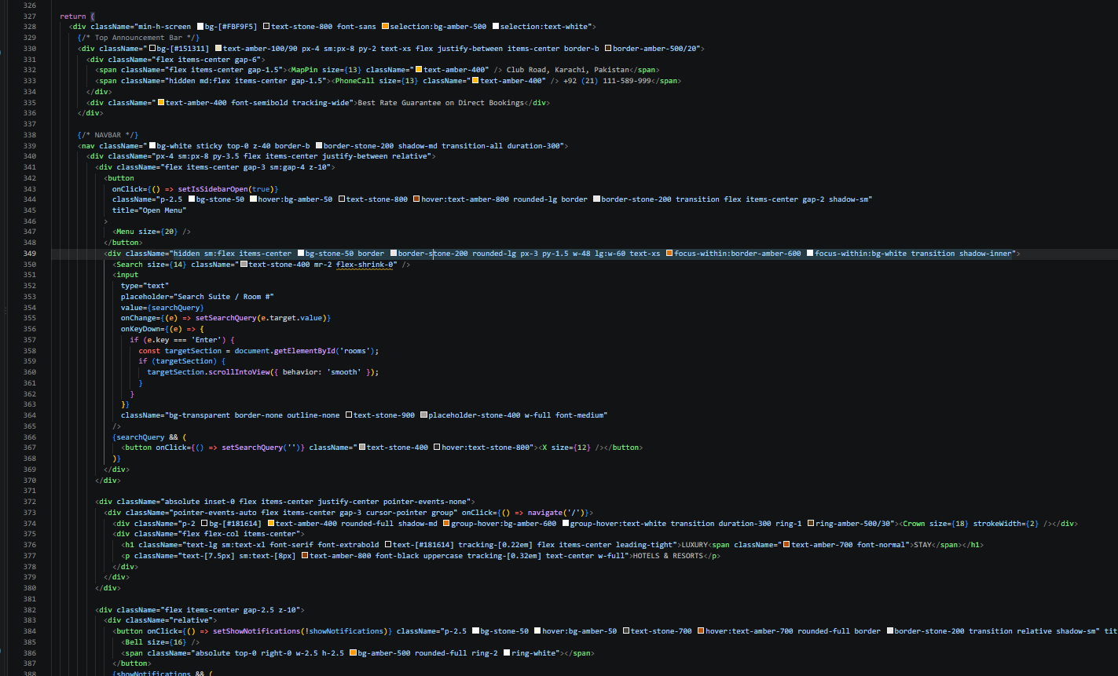
HOME PAGE:

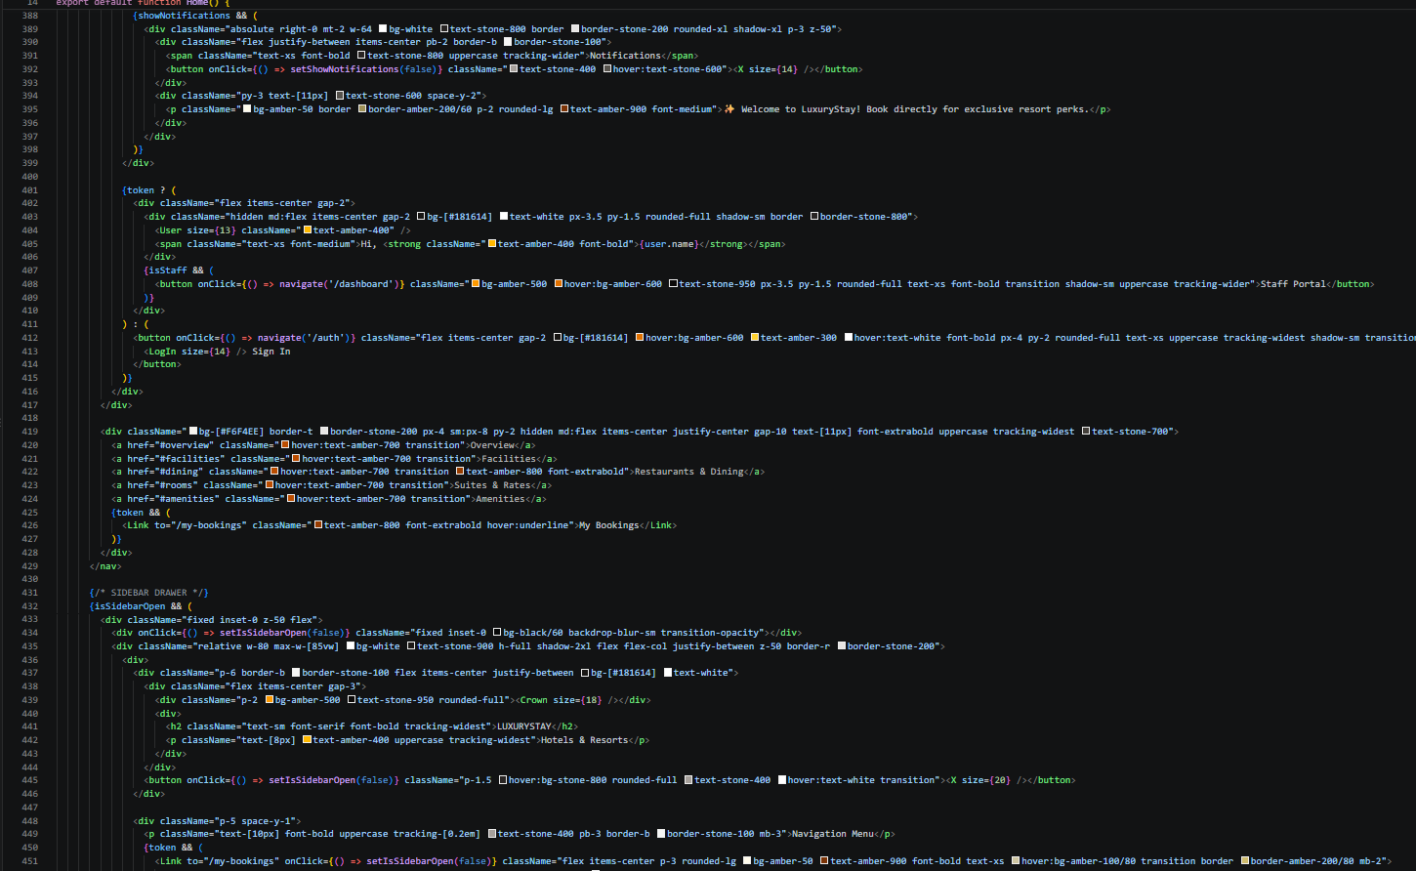

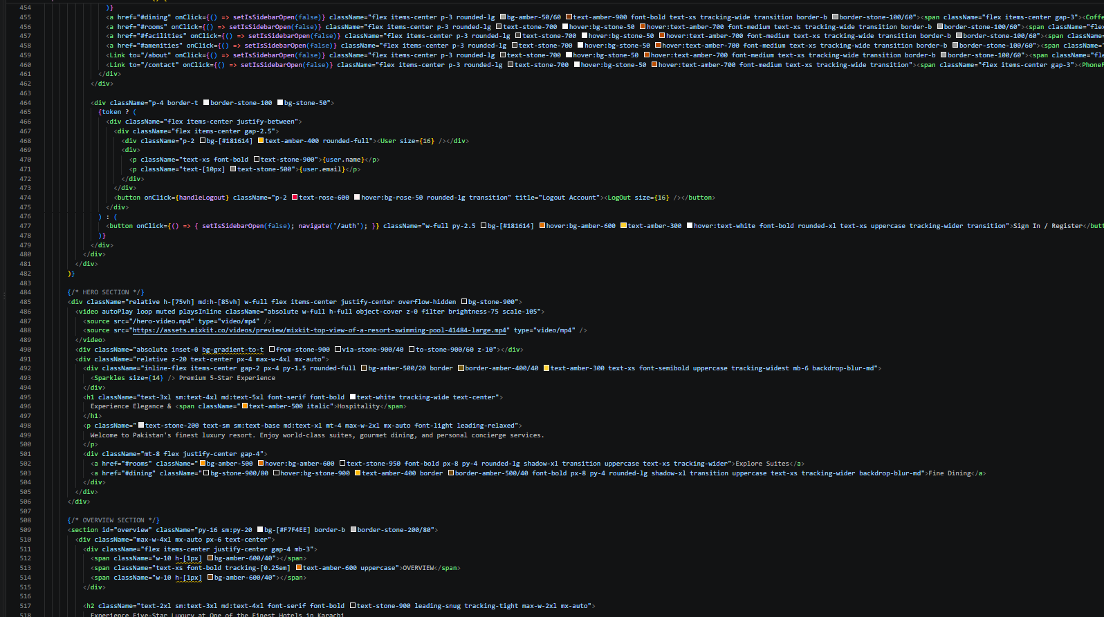

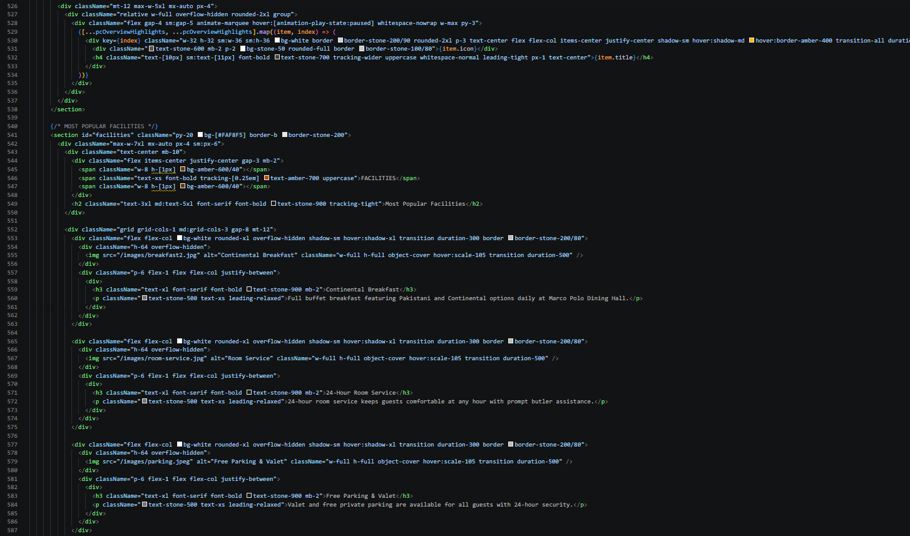

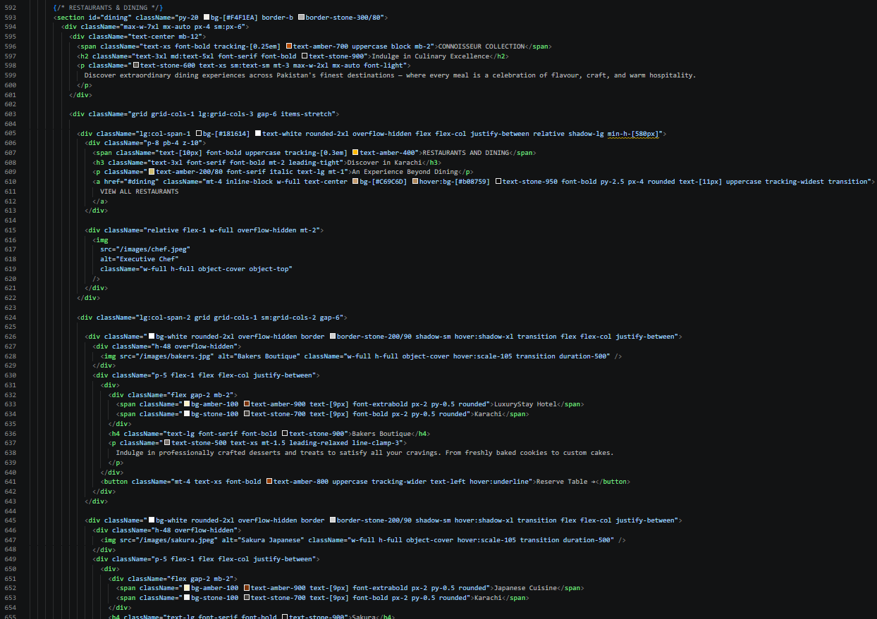

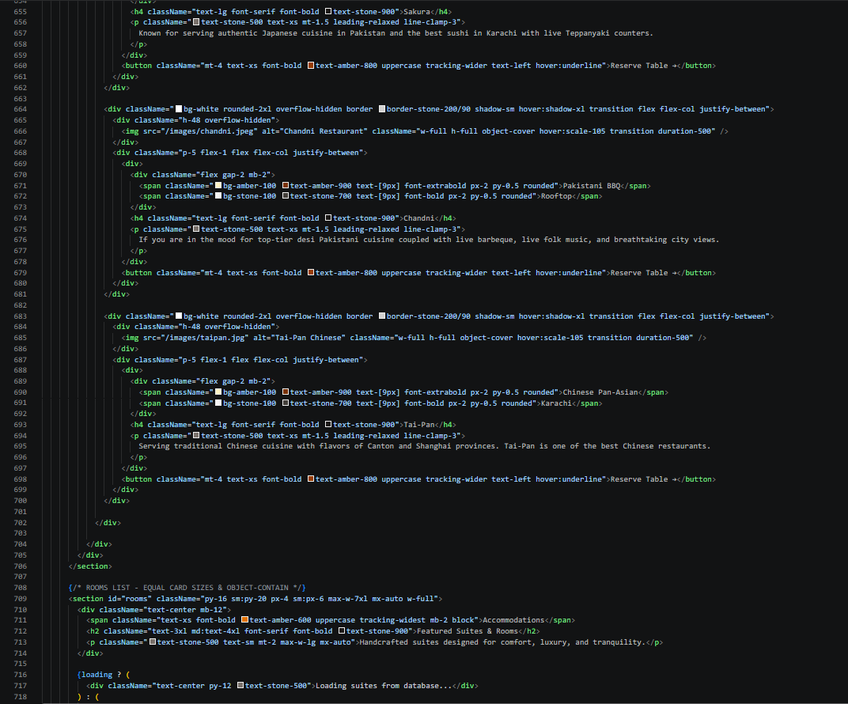

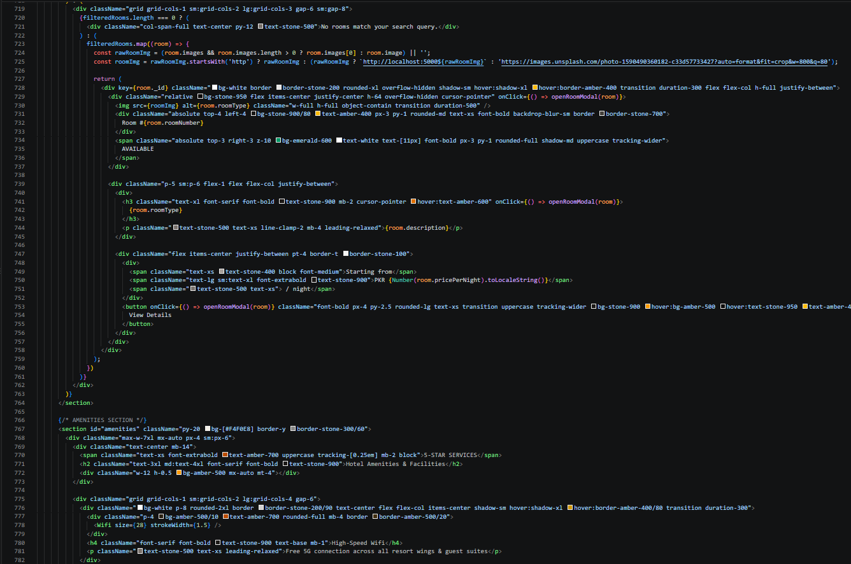

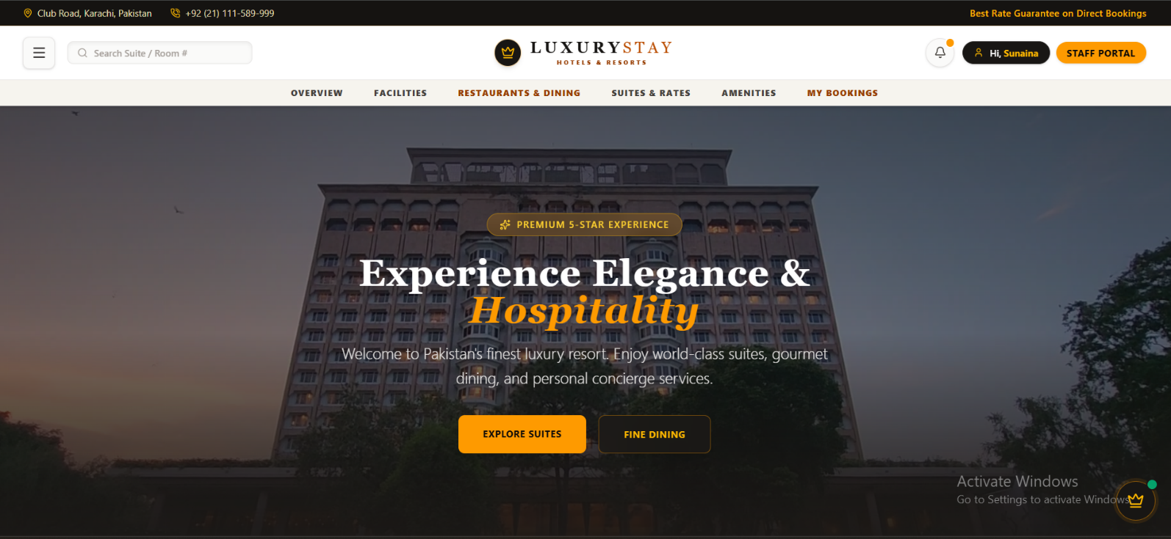
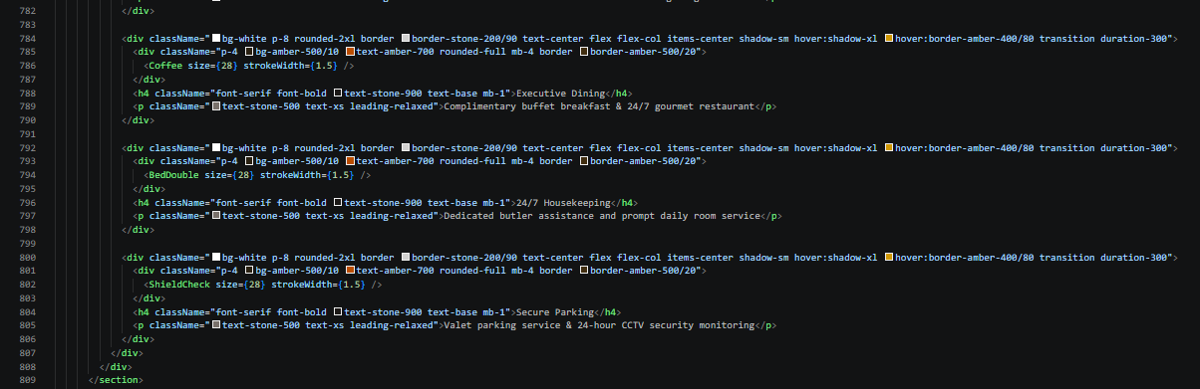

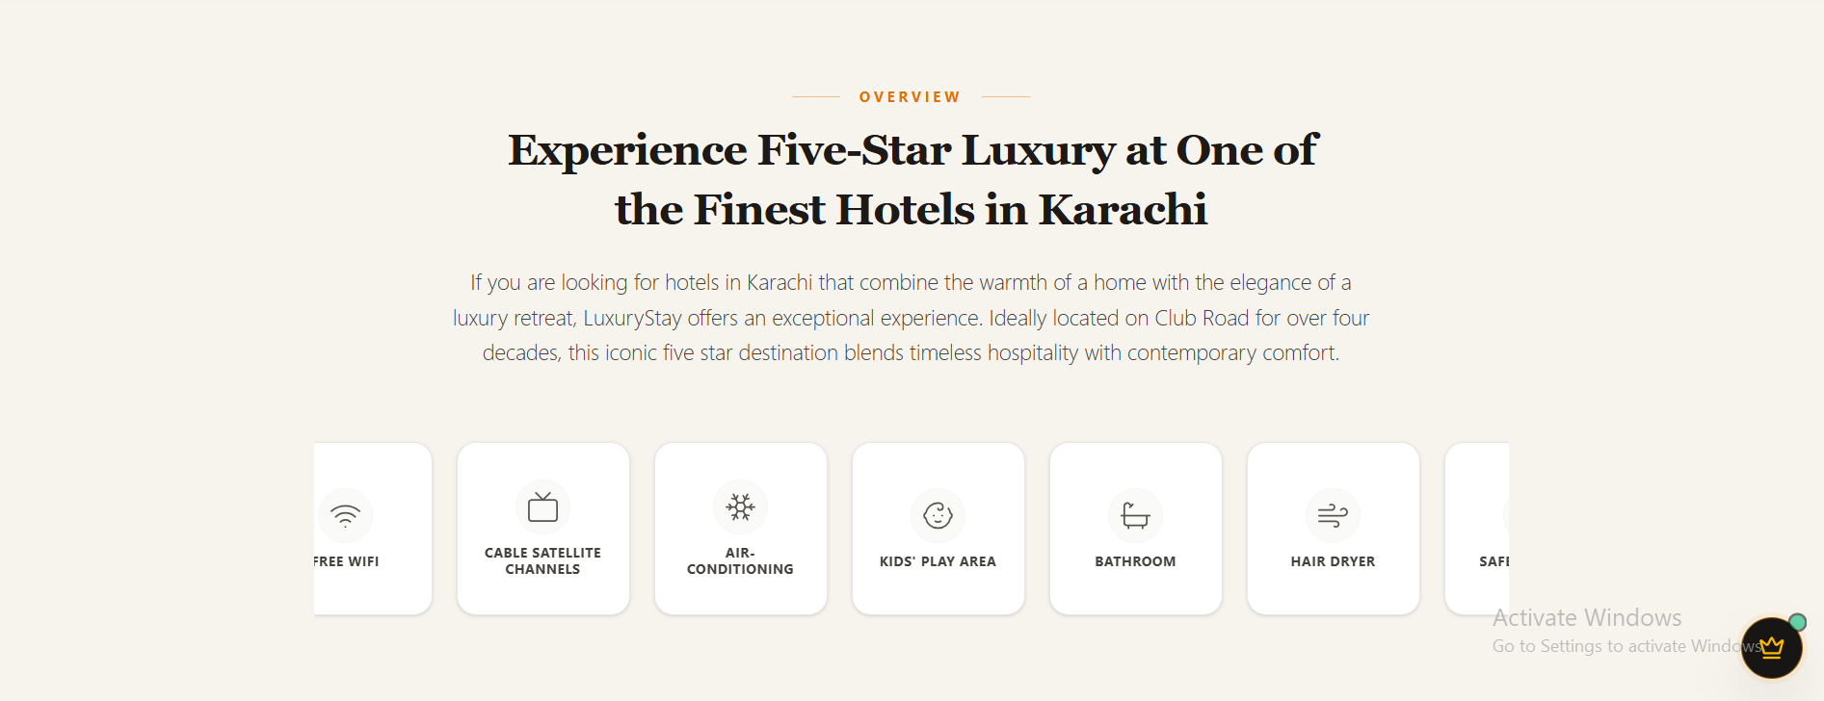

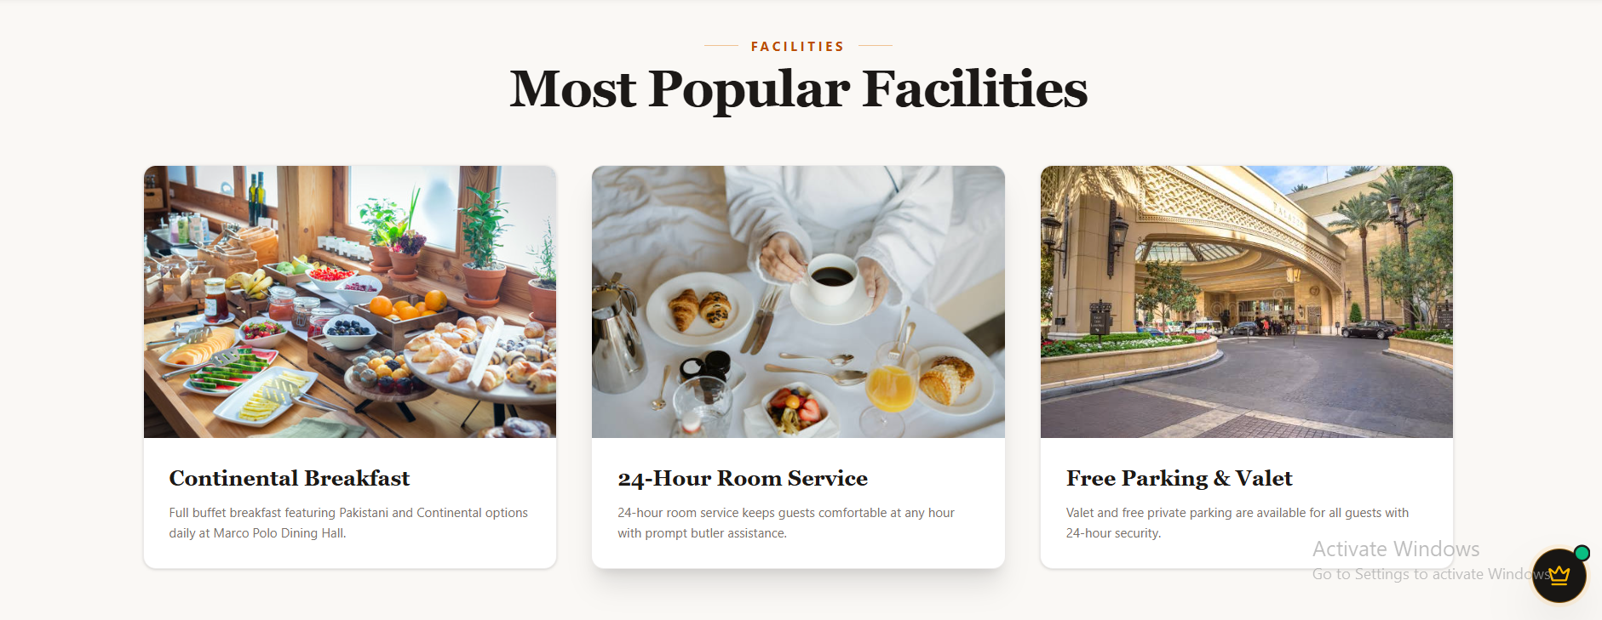

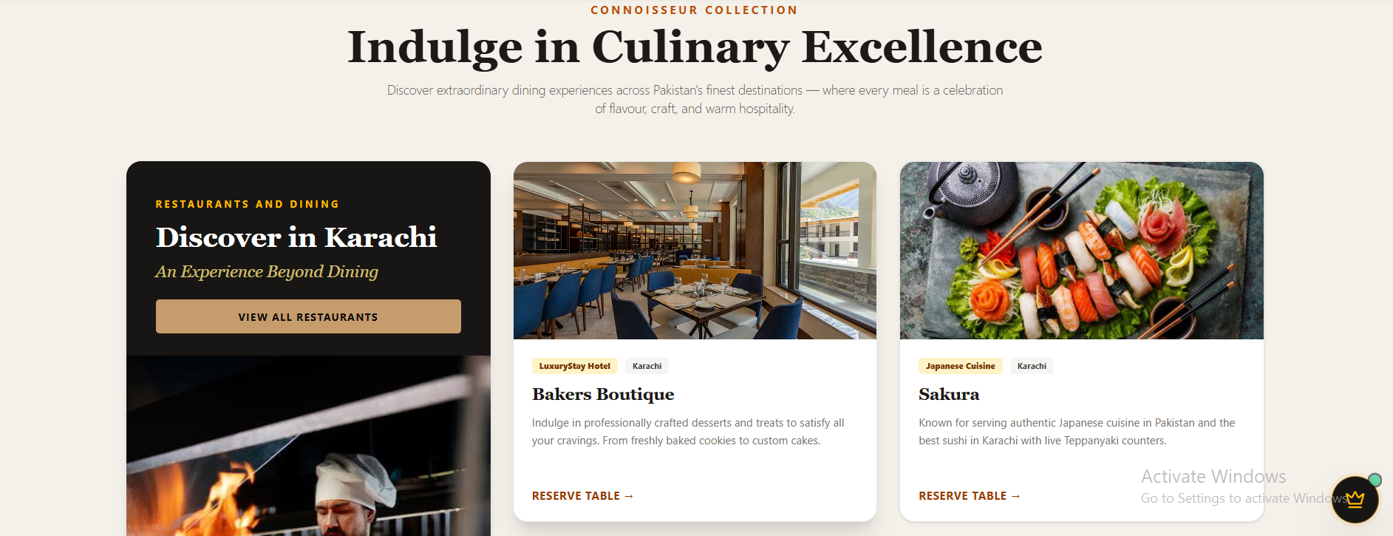

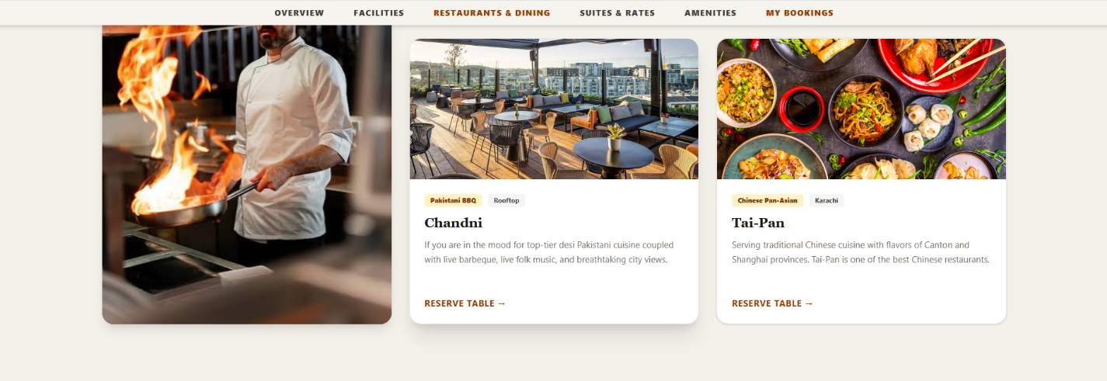

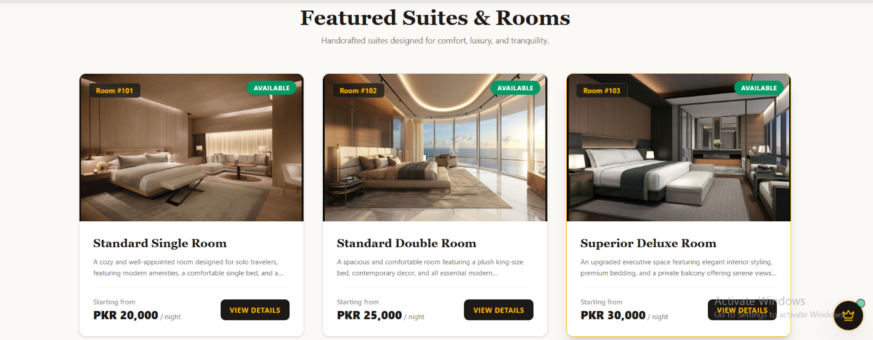

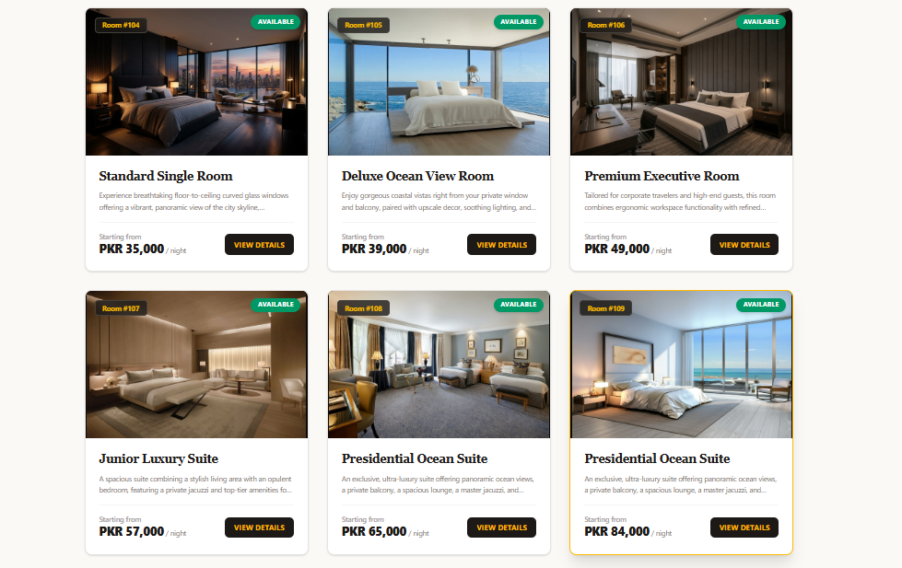
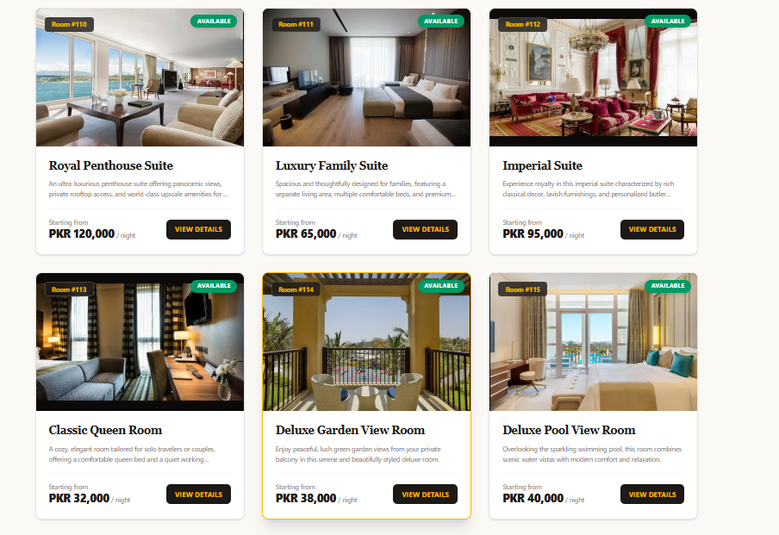

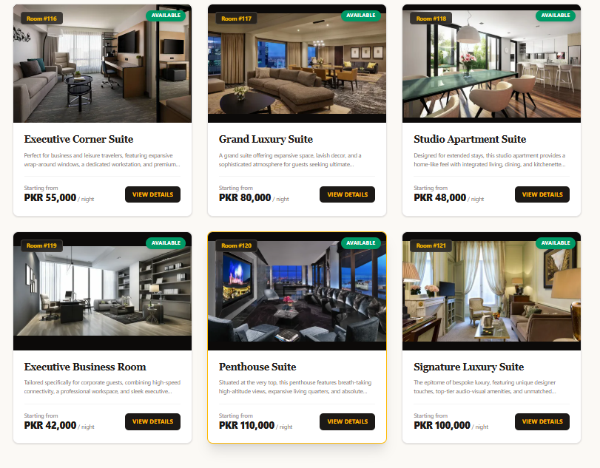

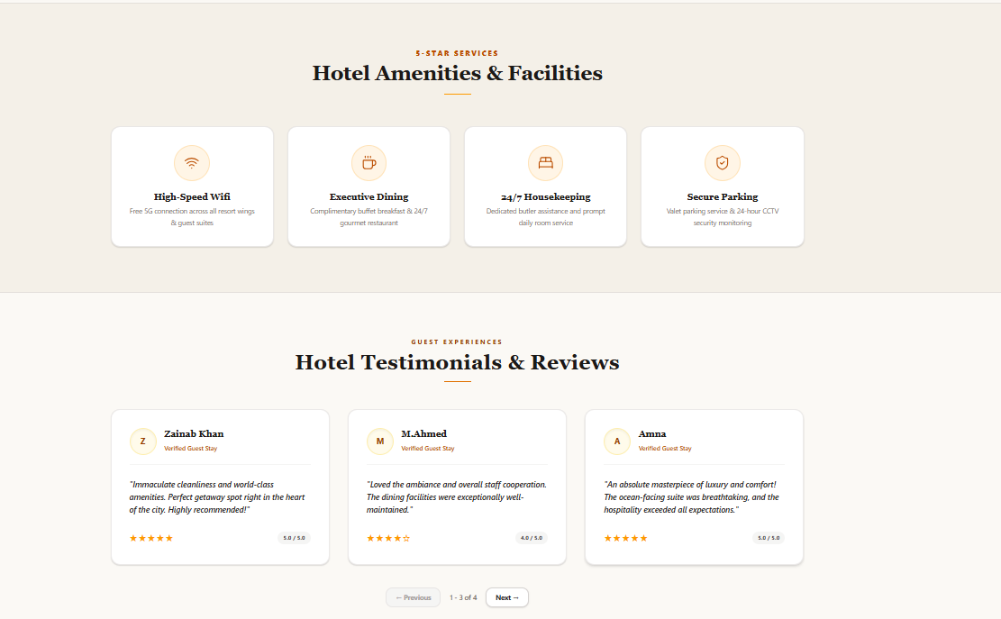

CHATBOT:
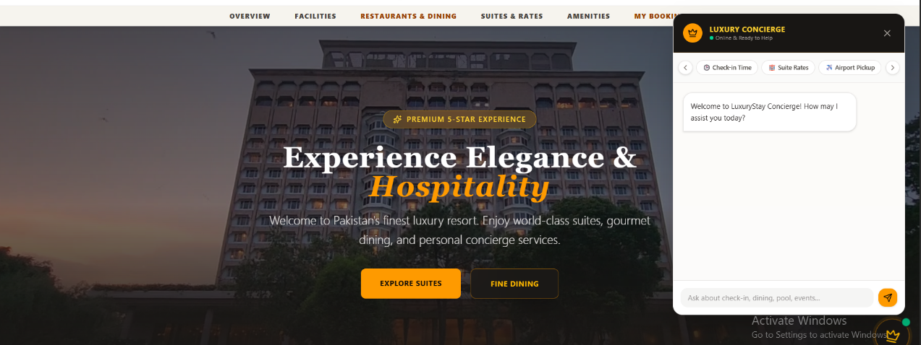

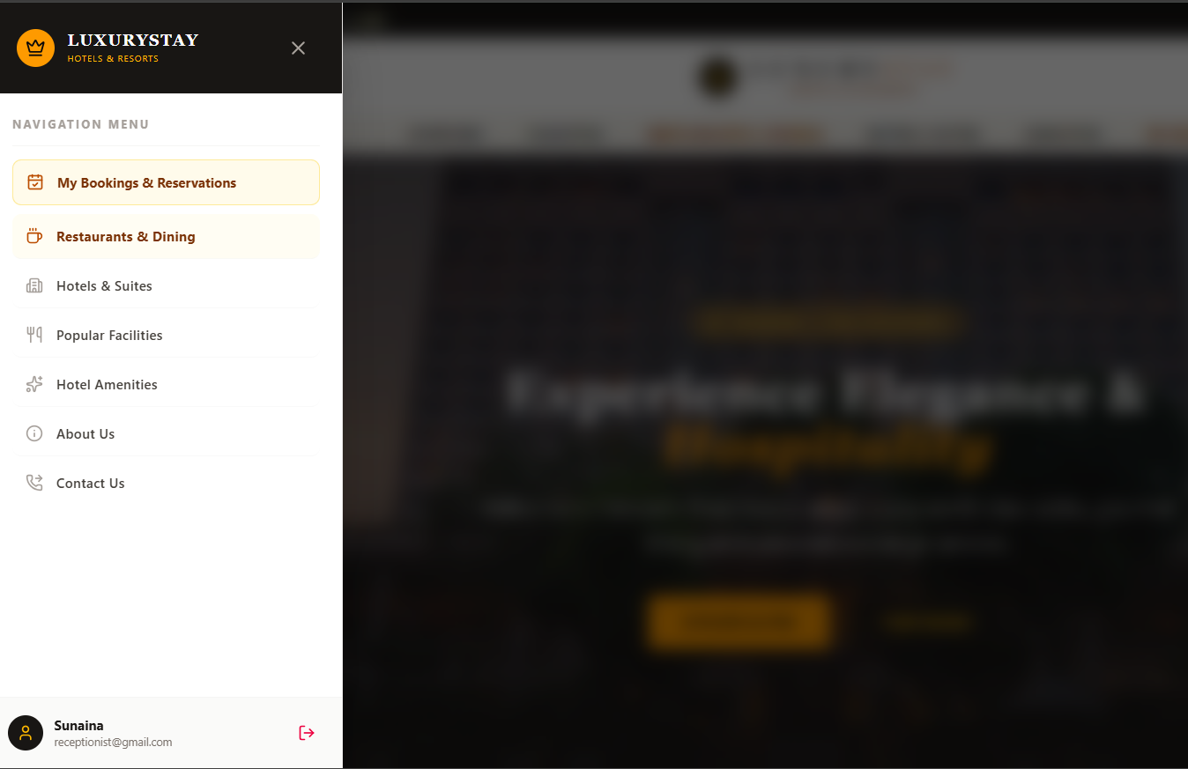

FOOTER:
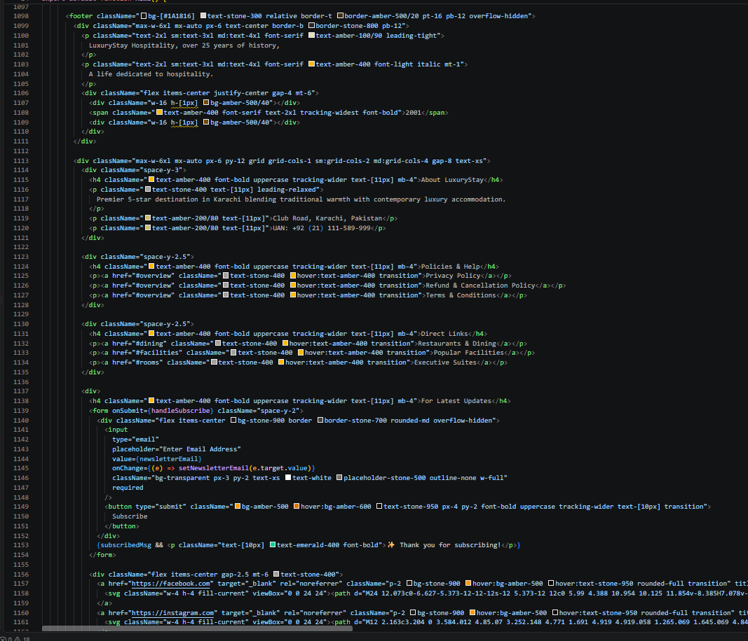
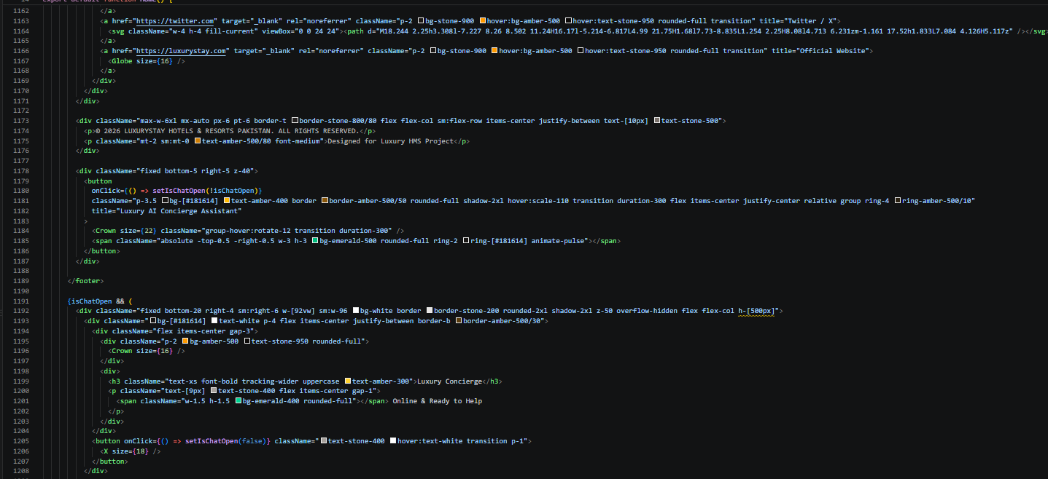
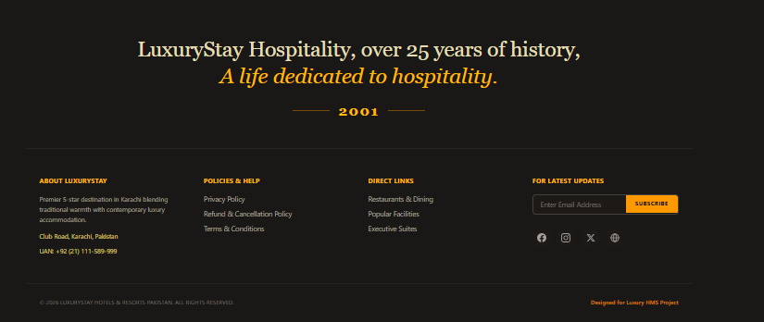

BOOKINGS:
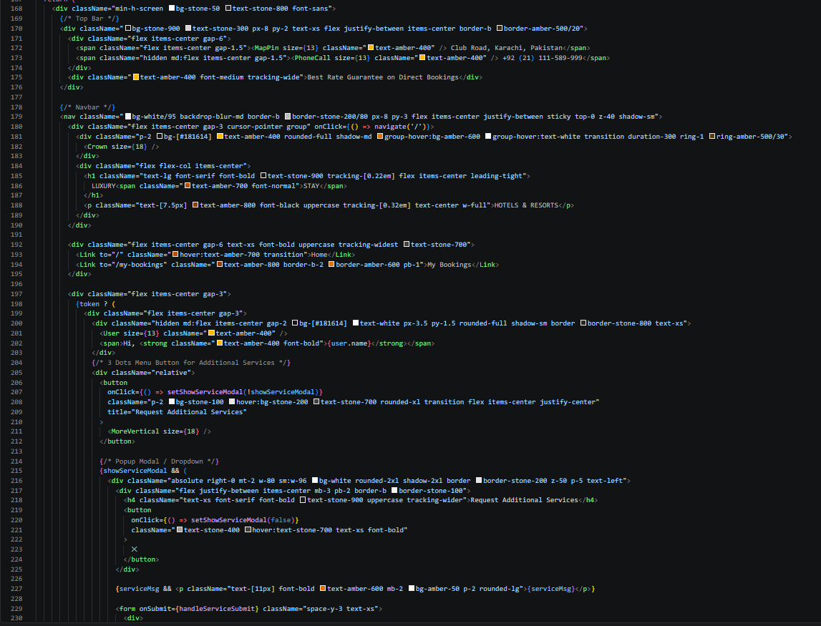

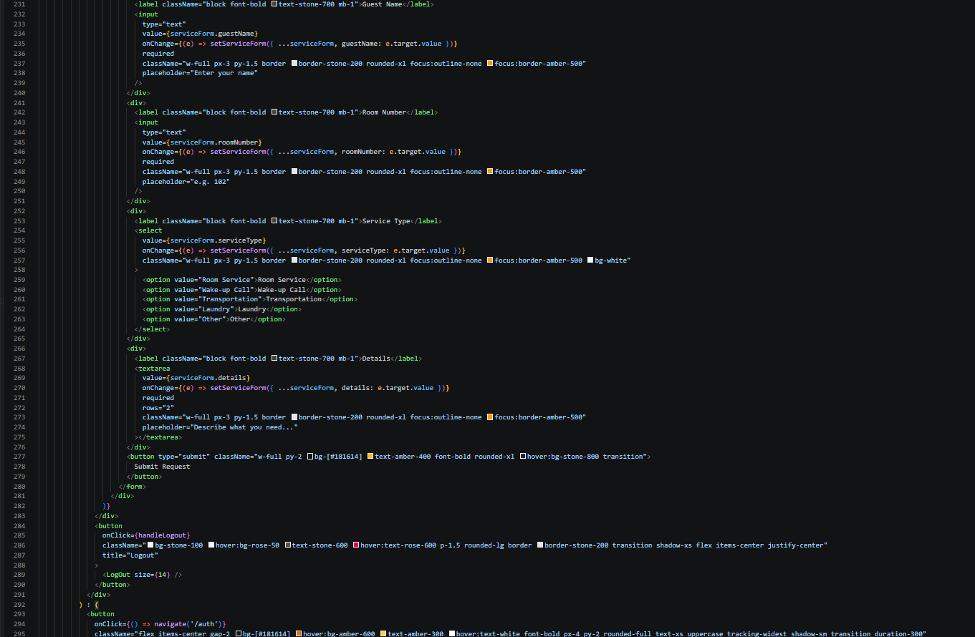

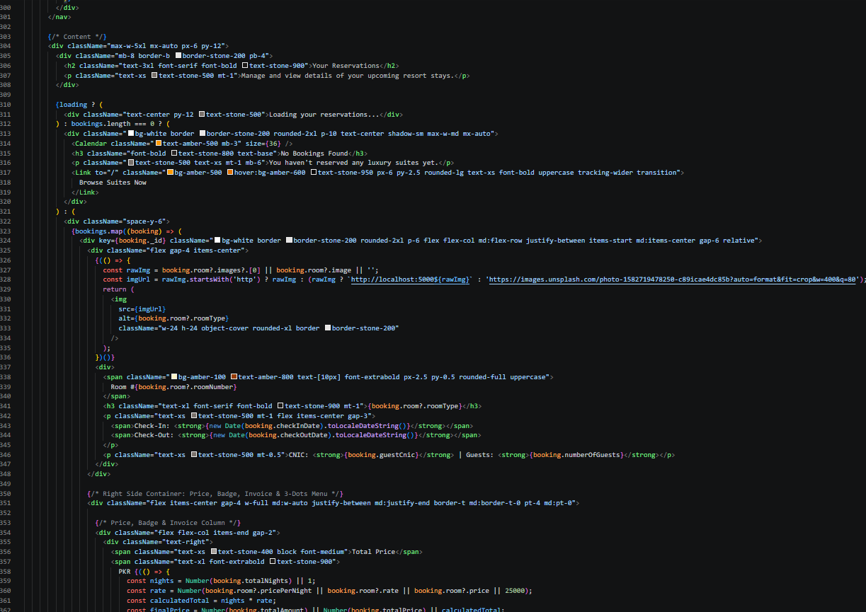

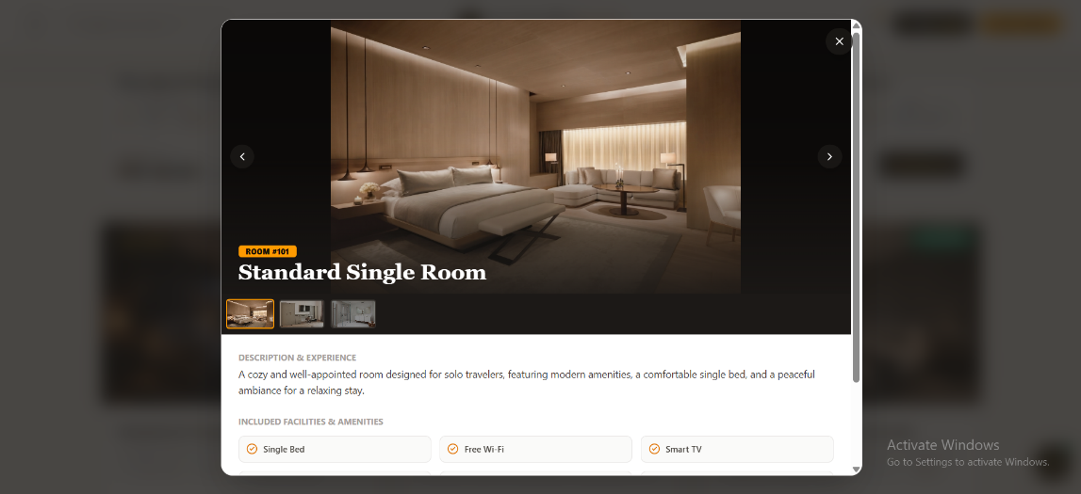
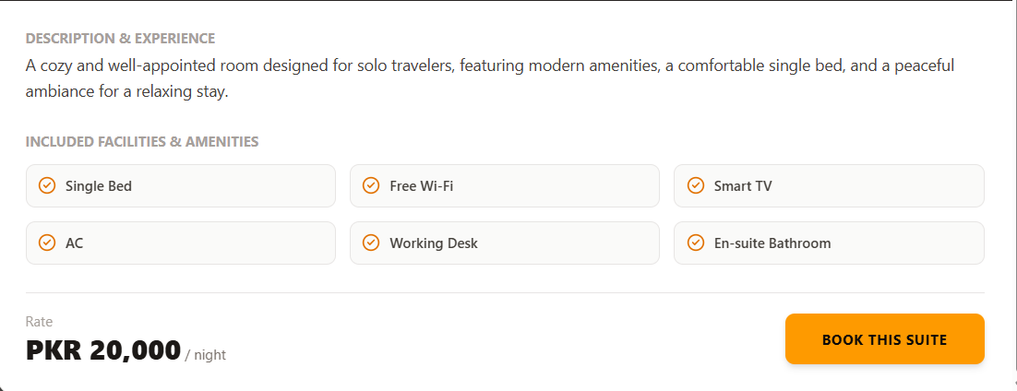
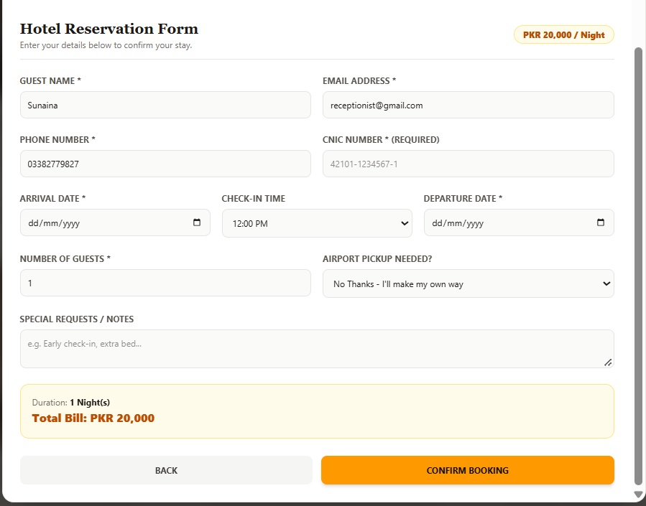

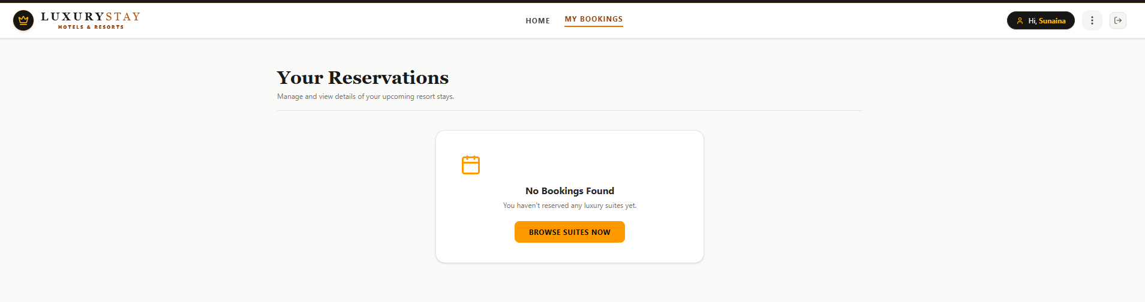
ABOUT PAGE:
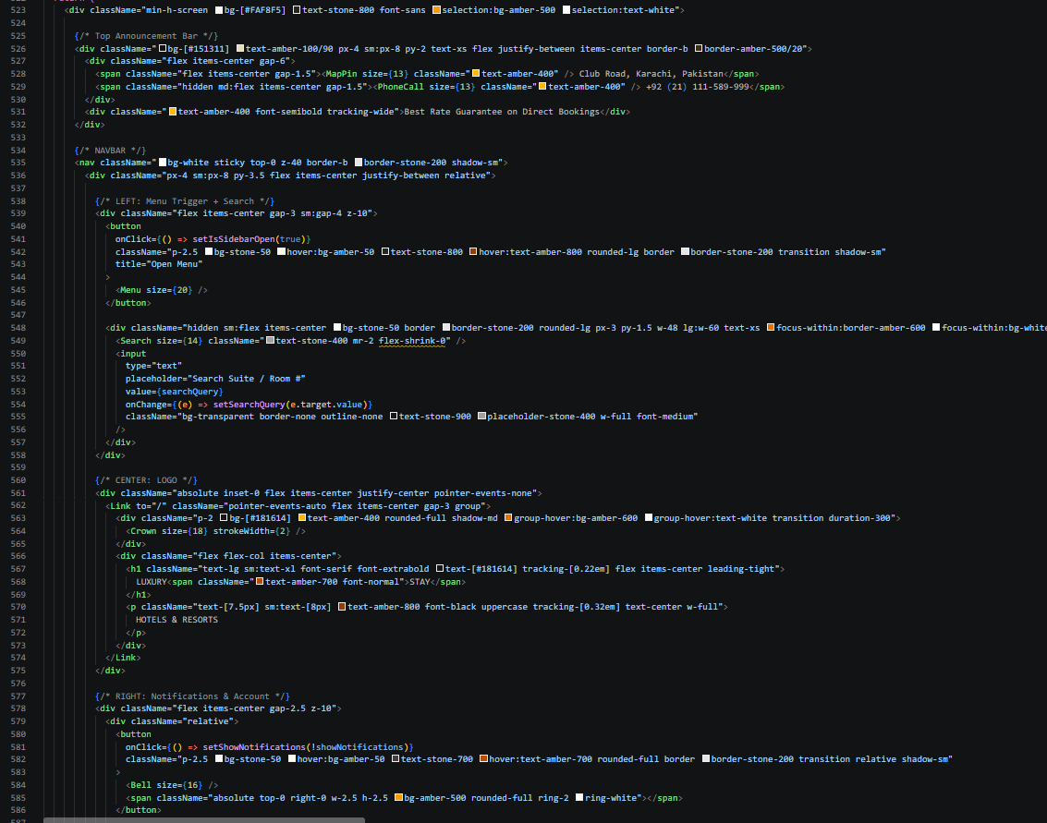

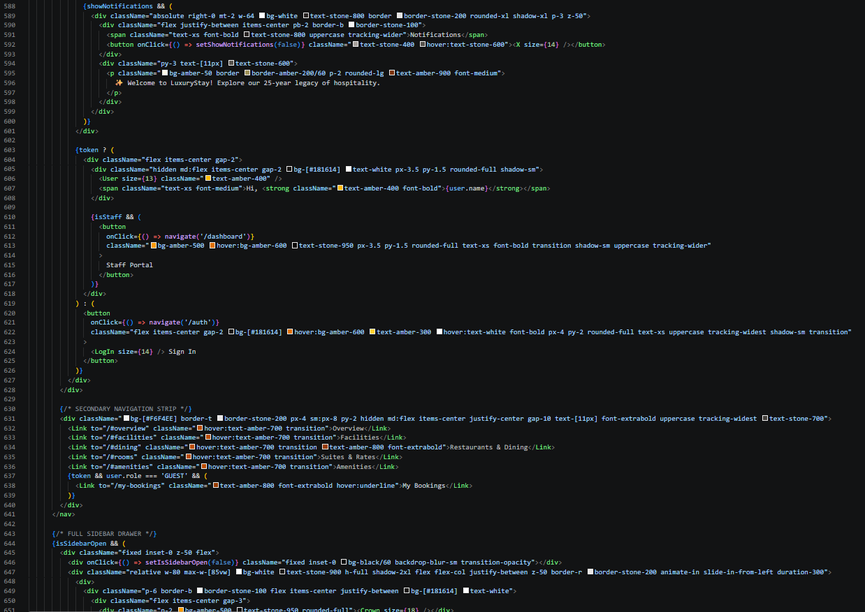

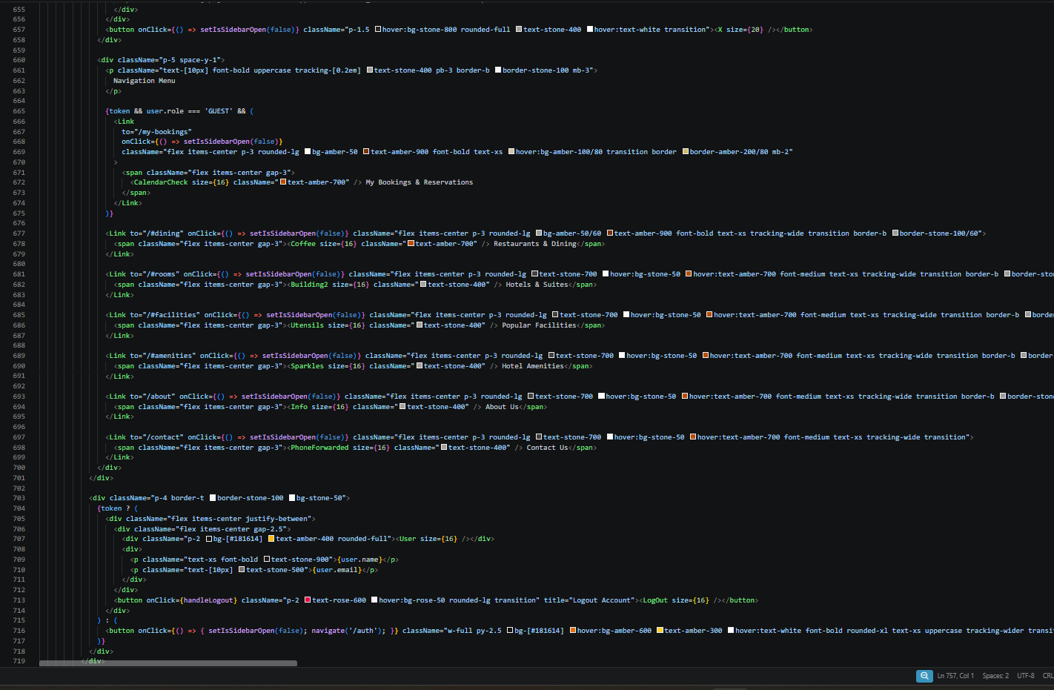

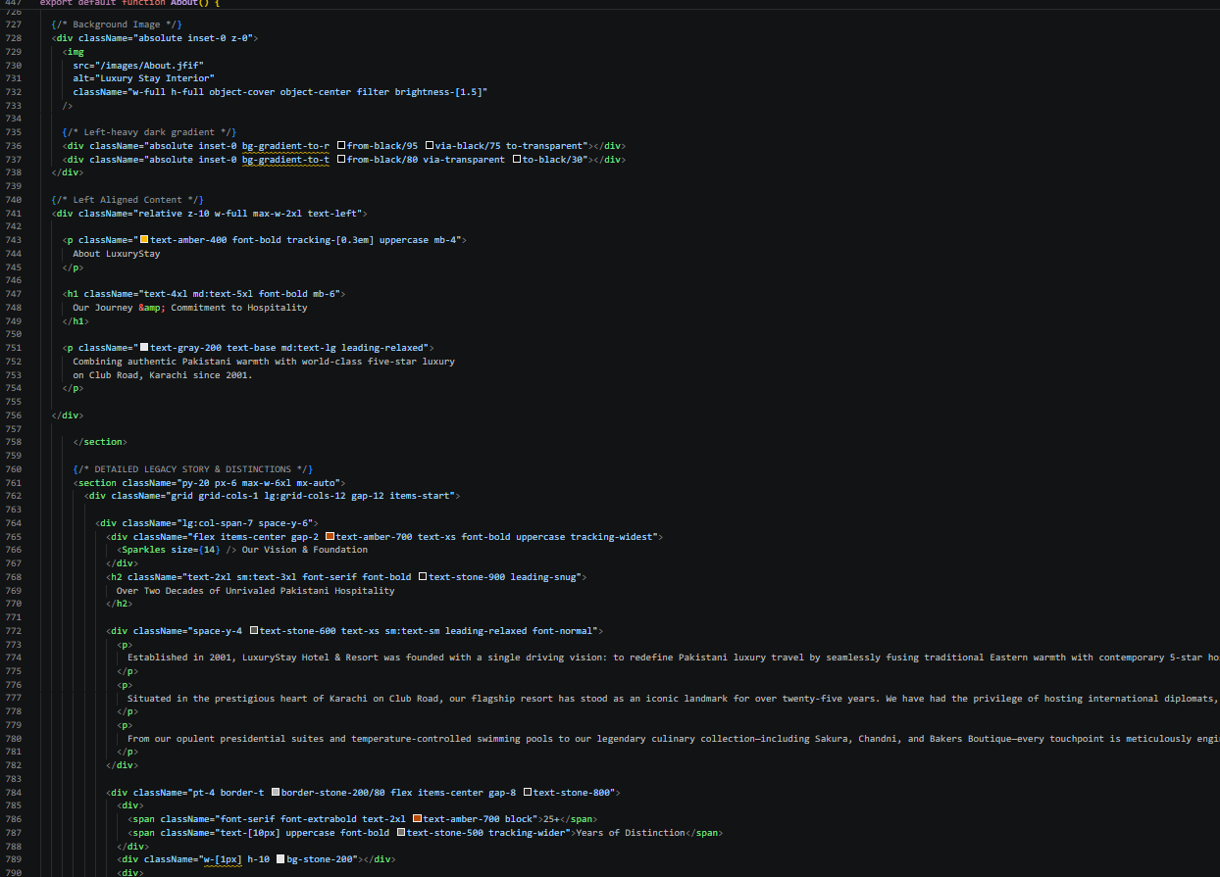

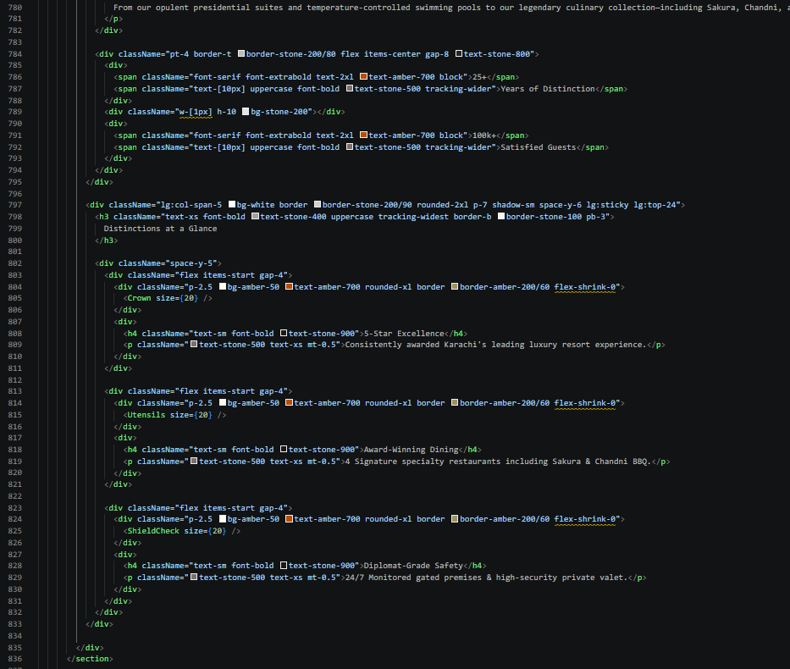

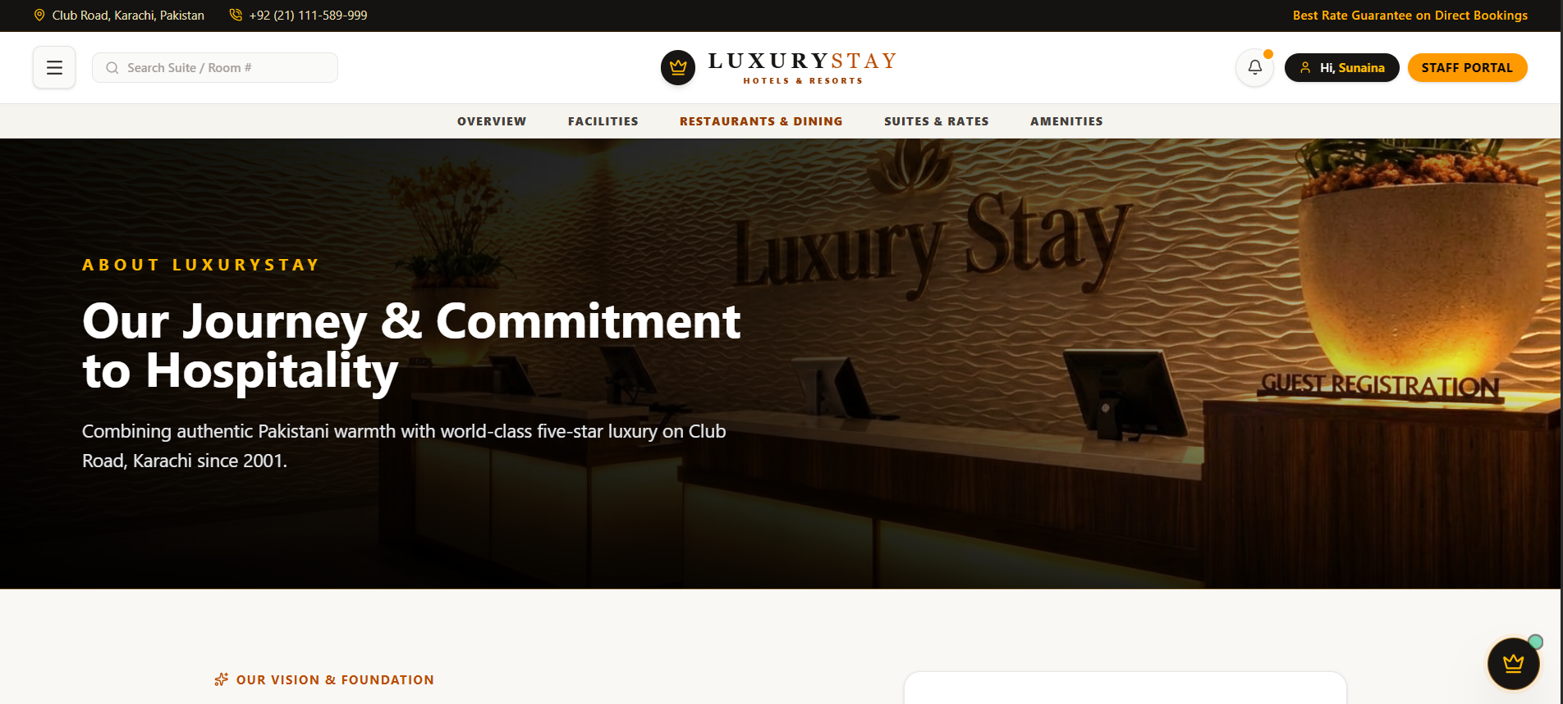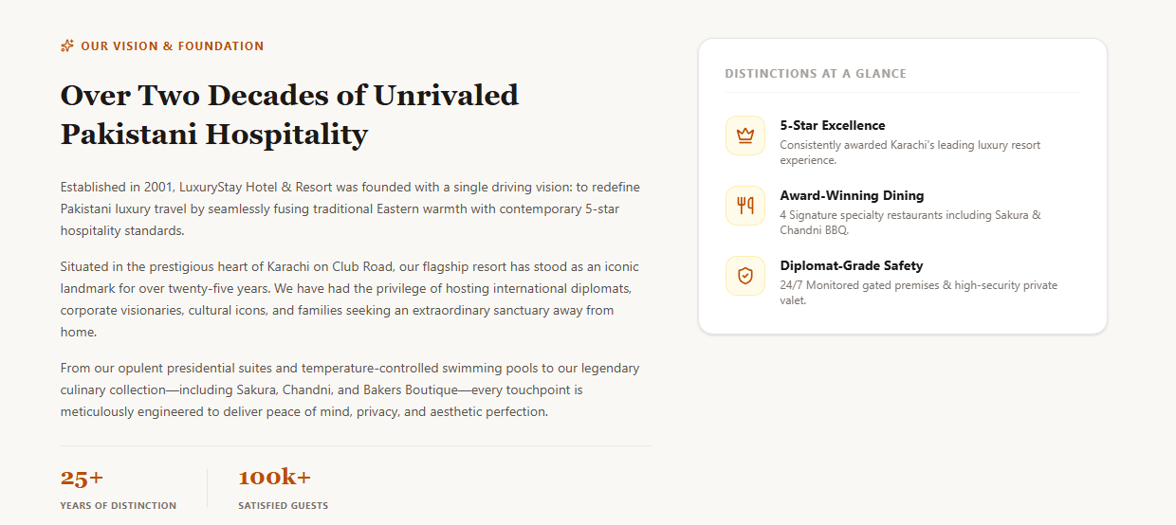

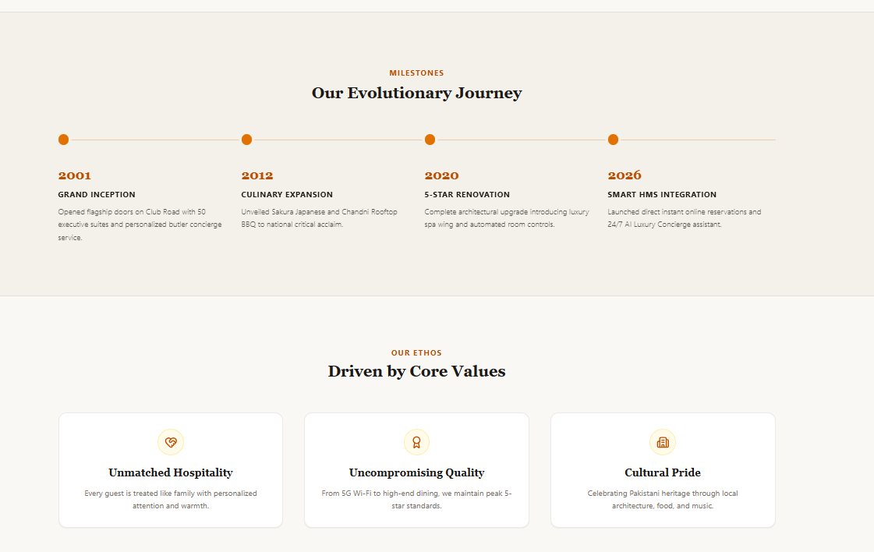

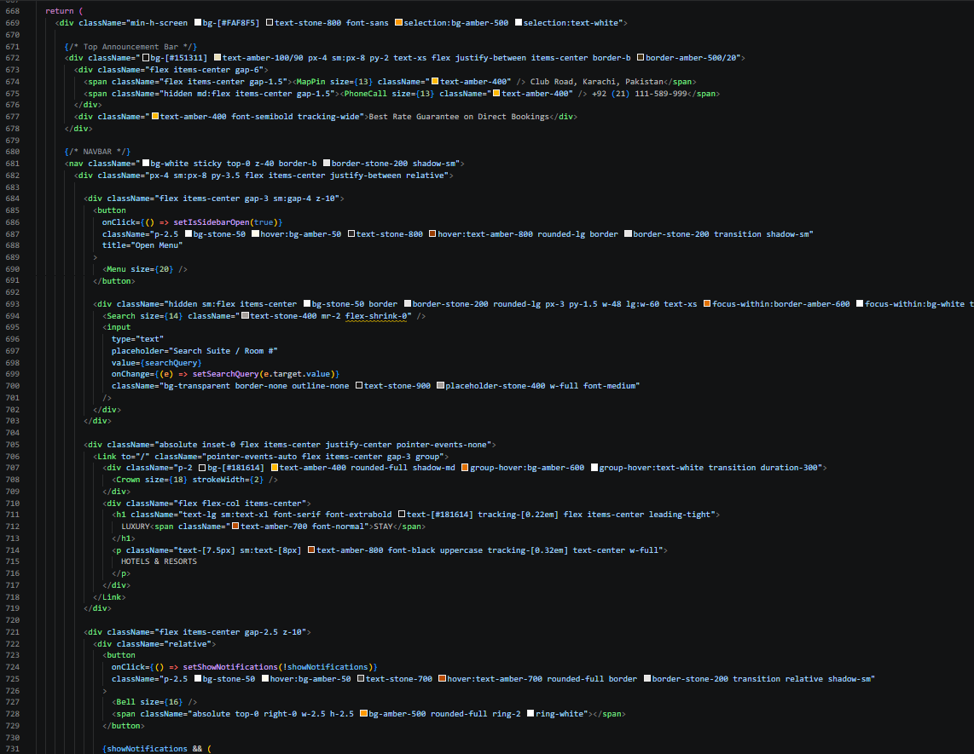
CONTACT PAGE:

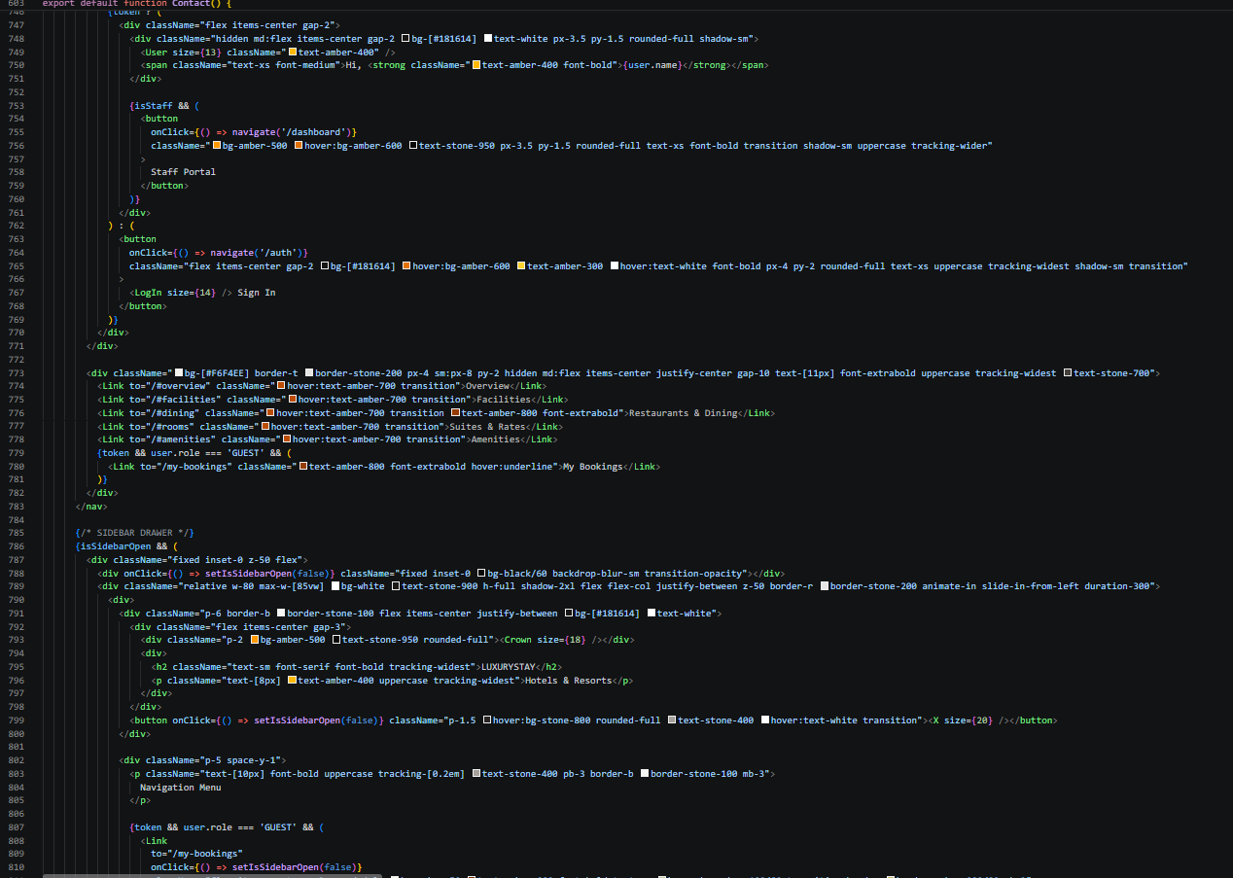
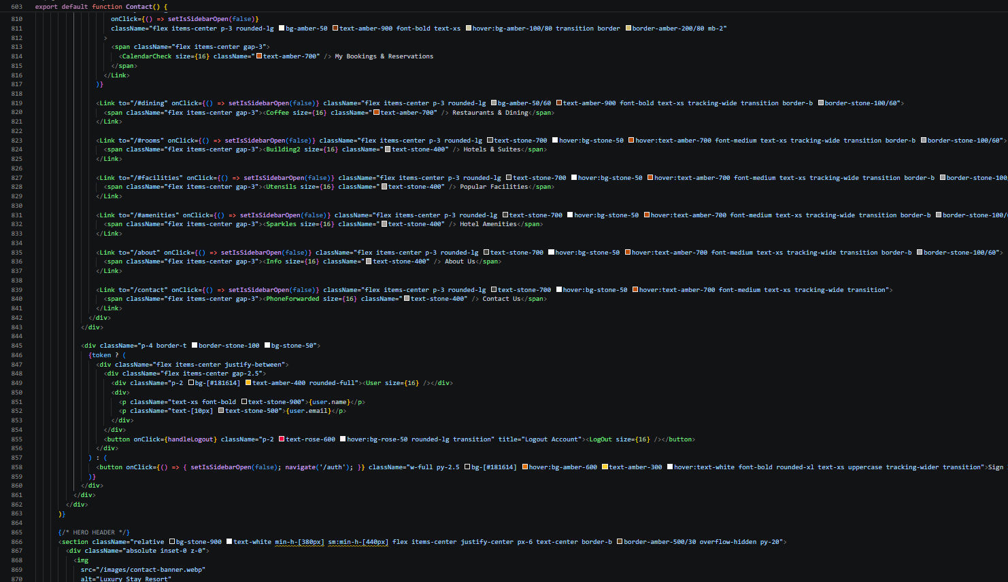

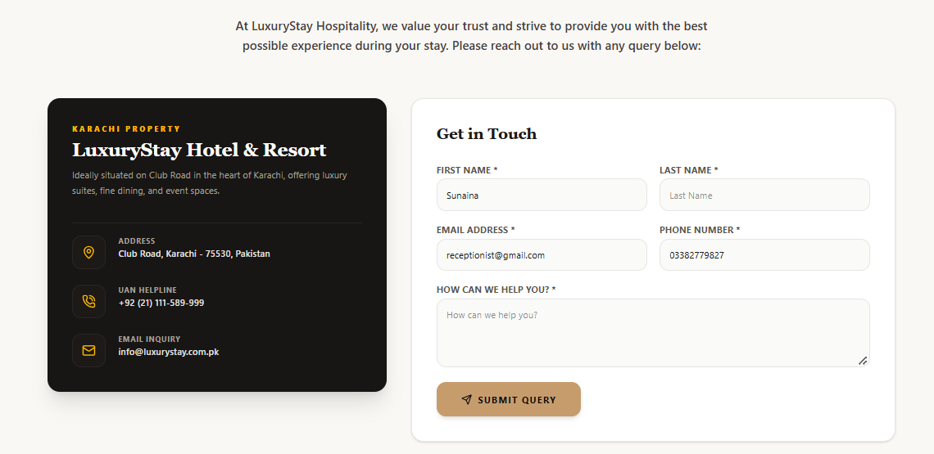
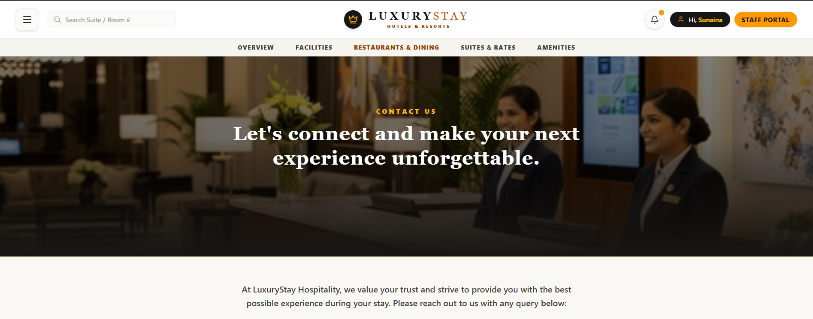

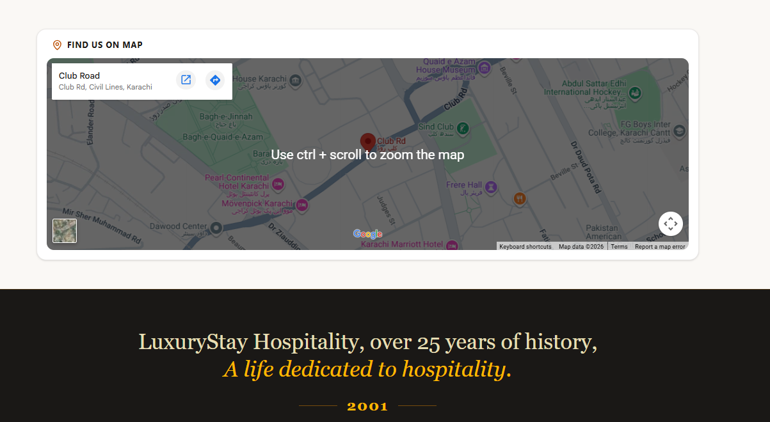

ADMIN PANEL:

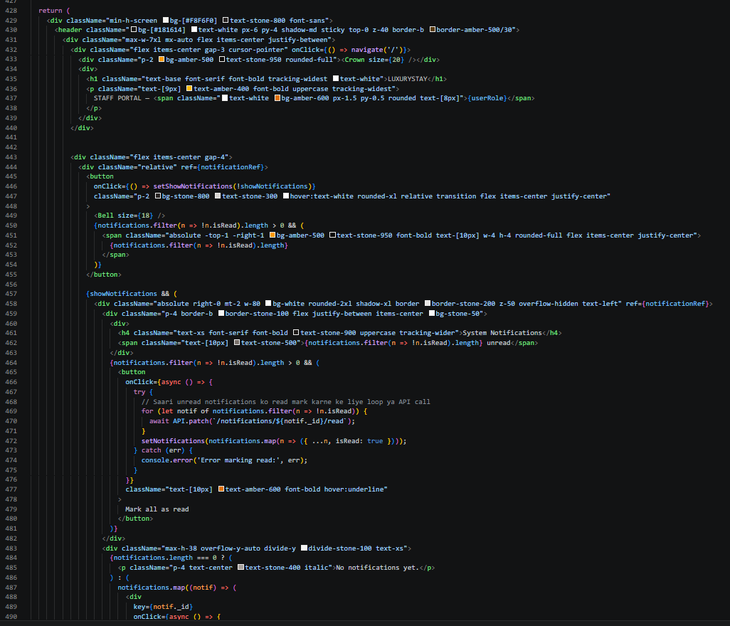

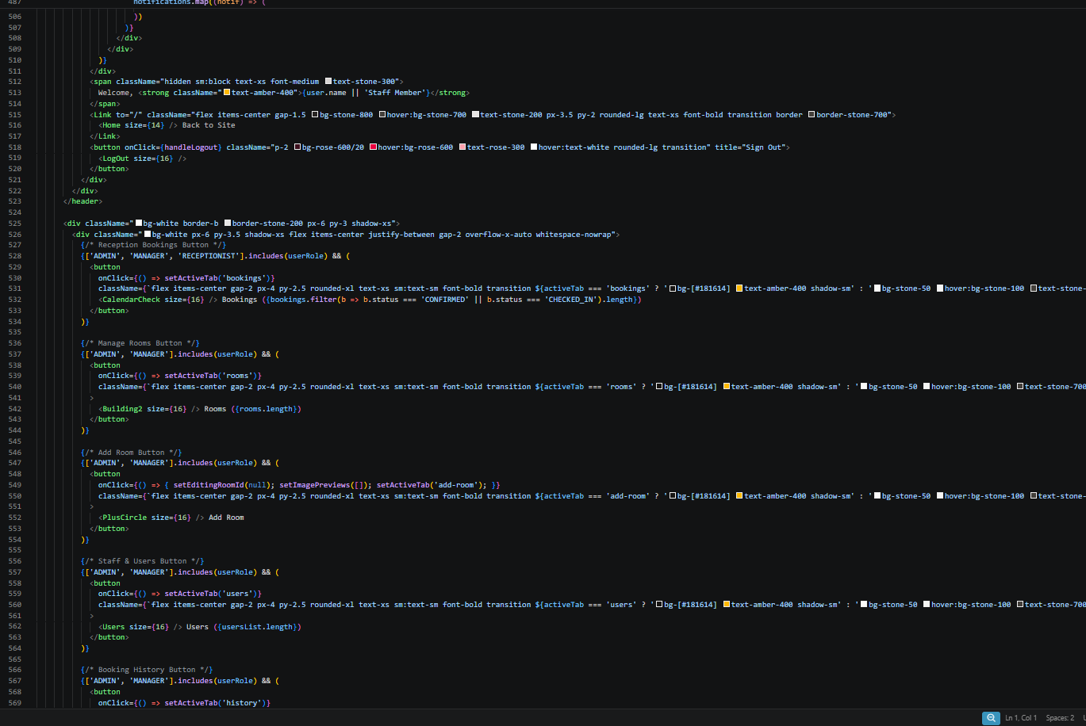

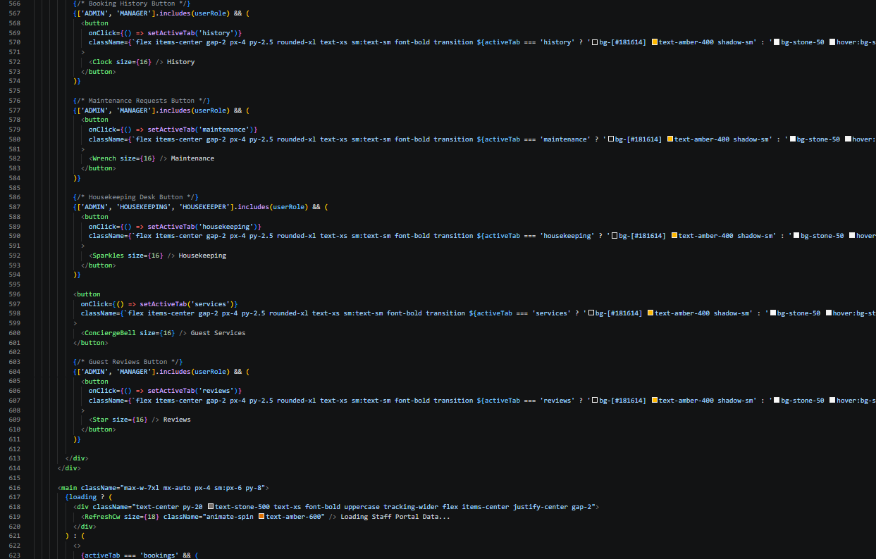
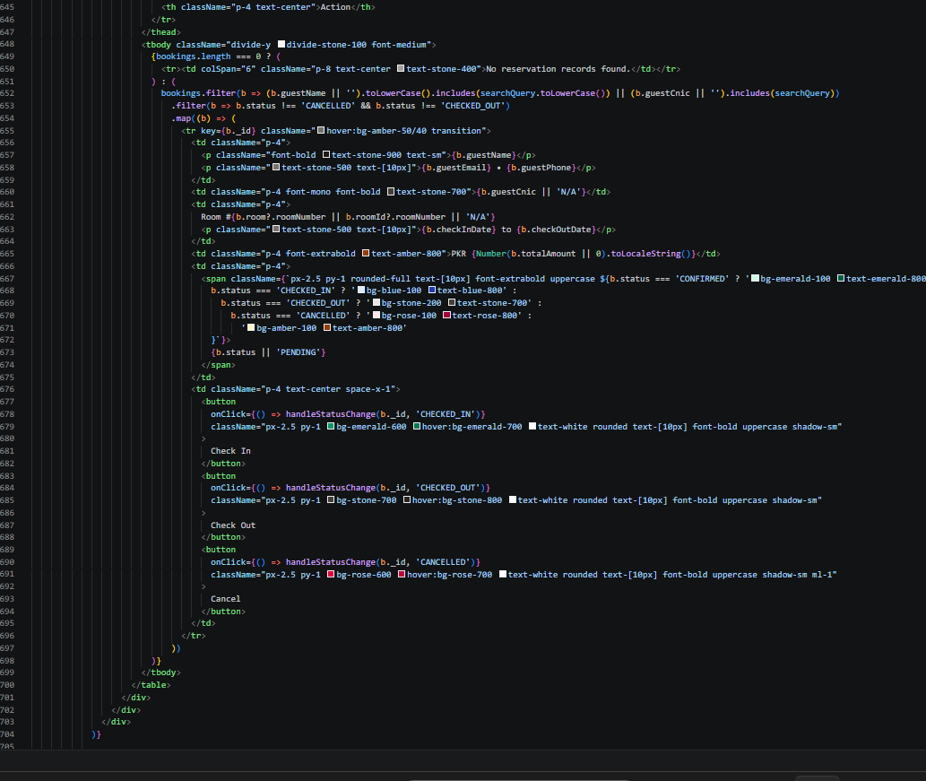

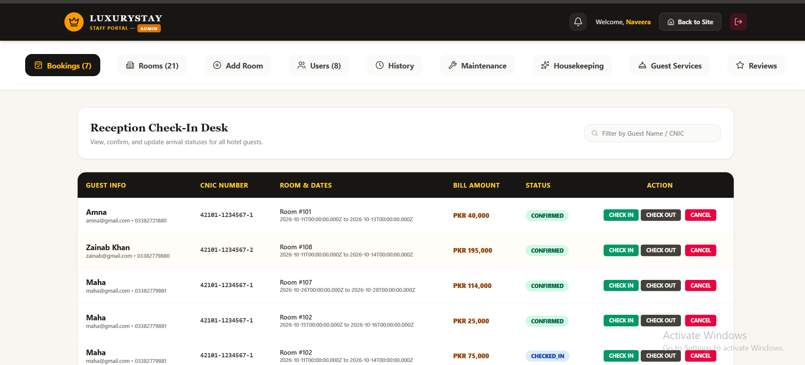

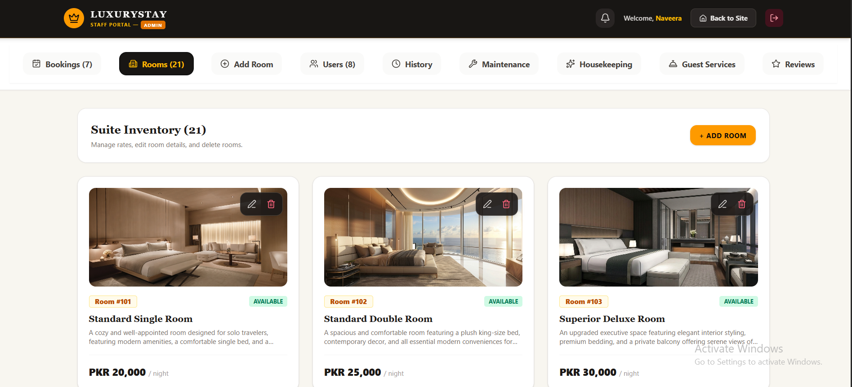

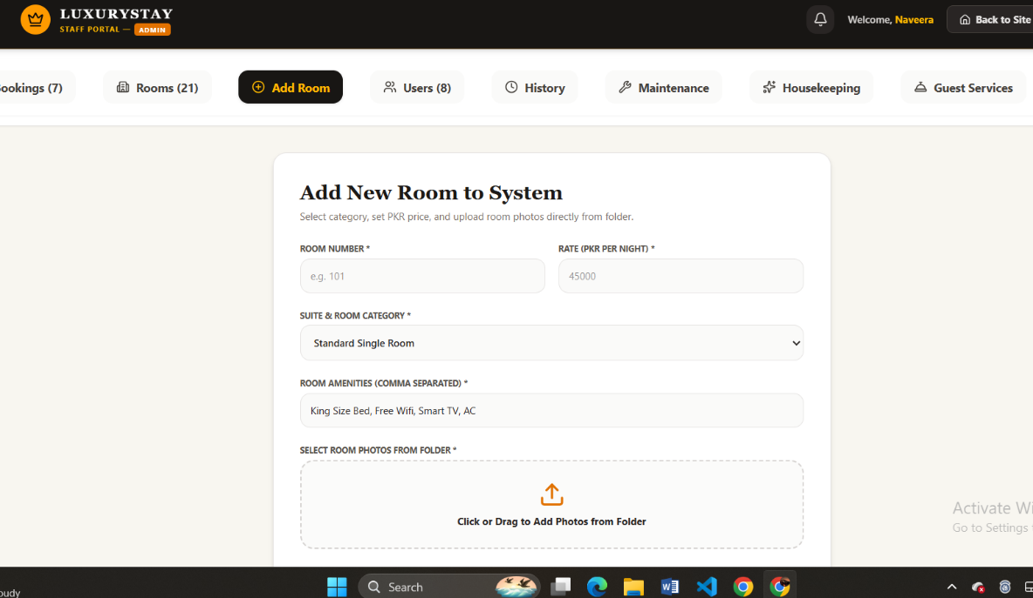

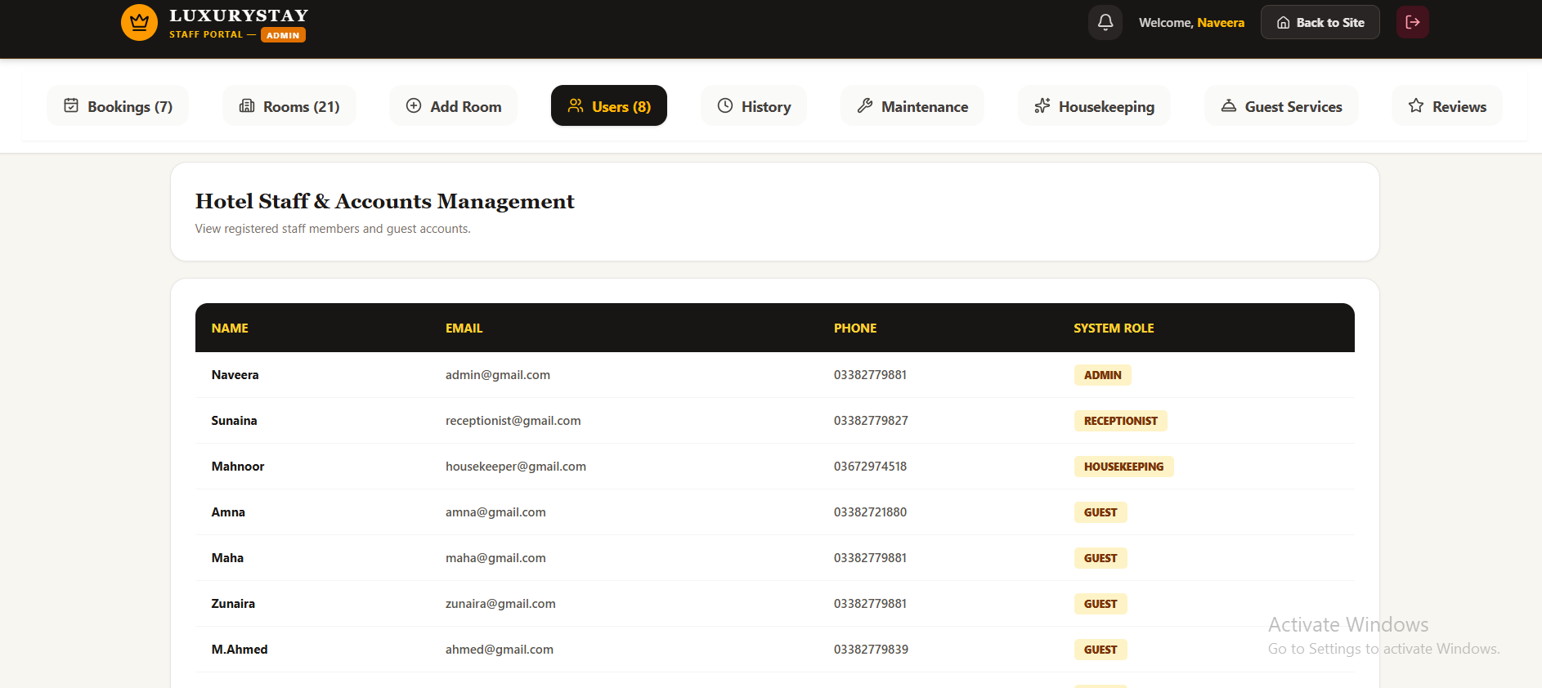

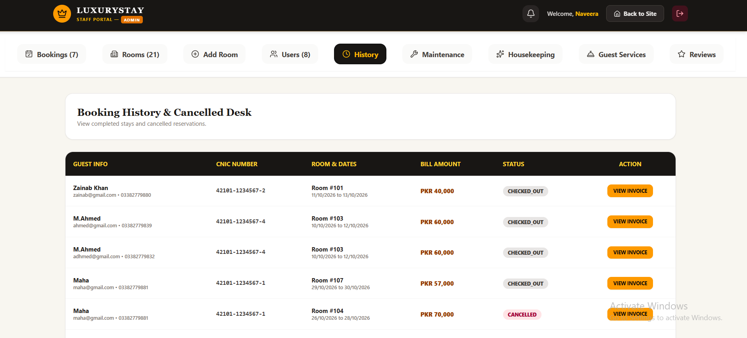

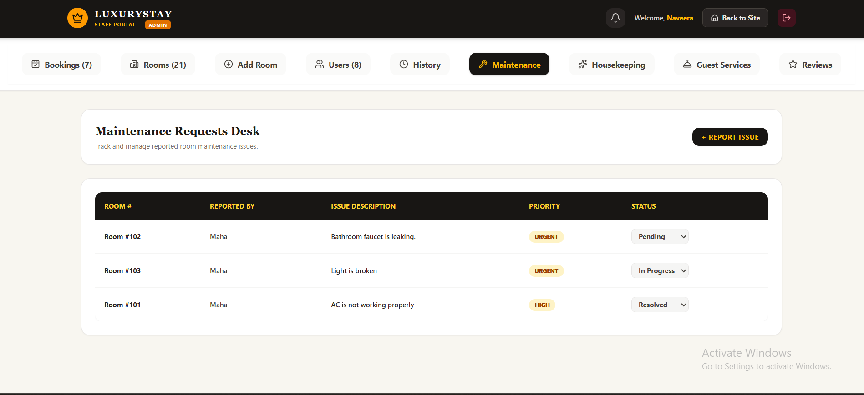
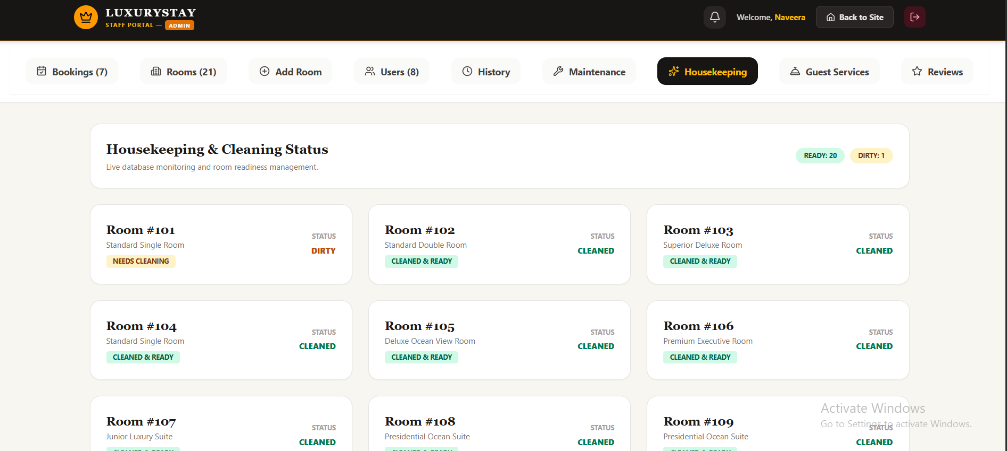

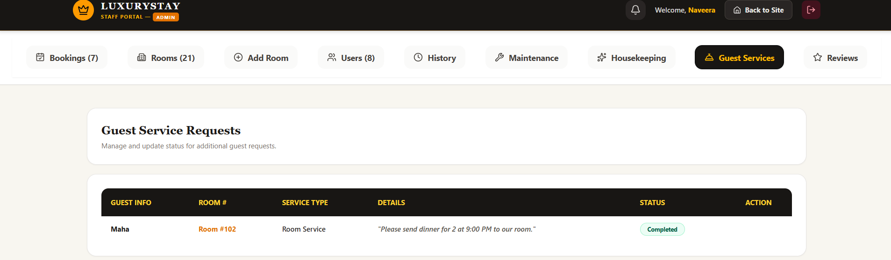

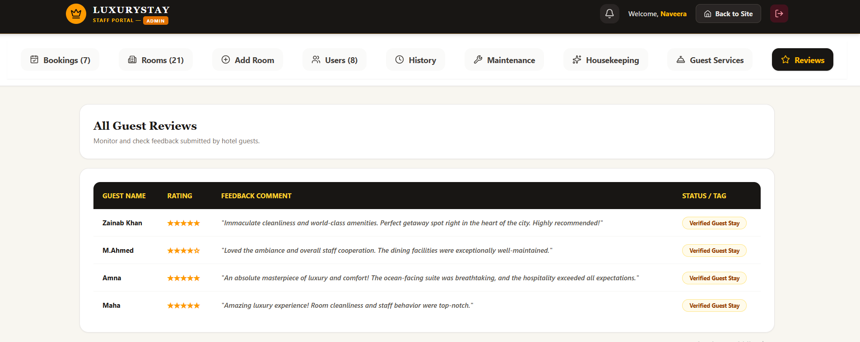

RECEPTIONIST:
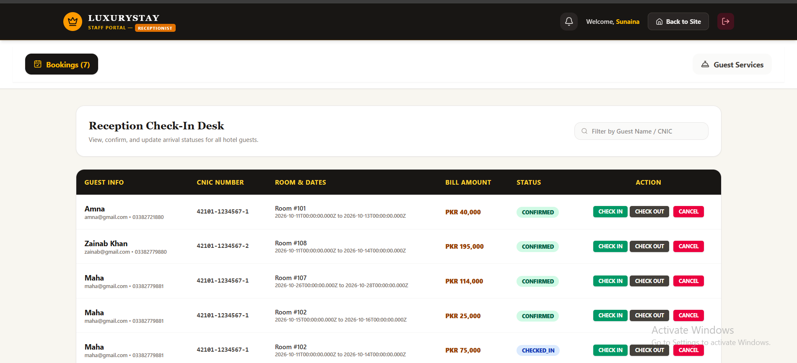

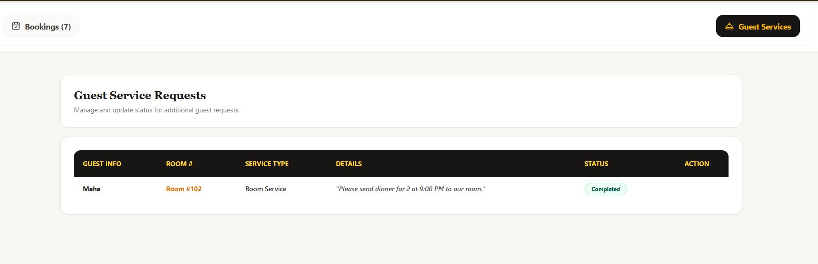

HOUSEKEEPING:

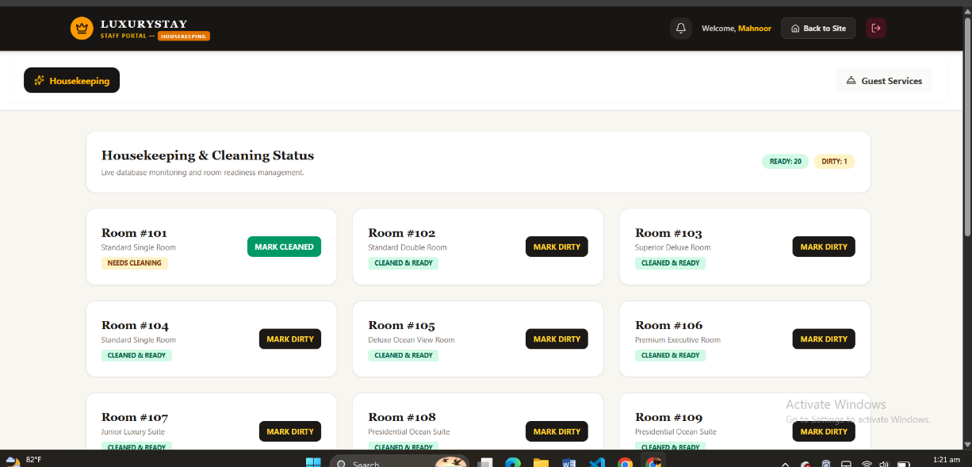

DATABASE

